Lab 4: Perform Website Footprinting

**Lab Scenario**

As a professional ethical hacker, you should be able to extract a variety of information about the target organization from its website; by performing website footprinting, you can extract important information related to the target organization’s website such as the software used and the version, operating system details, filenames, paths, database field names, contact details, CMS details, the technology used to build the website, scripting platform, etc. Using this information, you can further plan to launch advanced attacks on the target organization.

**Lab Objectives**

* Gather information about a target website using ping command line utility
* Gather information about a target website using Central Ops
* Extract a company’s data using Web Data Extractor
* Mirror the target website using HTTrack Web Site Copier
* Gather a wordlist from the target website using CeWL

**Overview of Website Footprinting**

Website footprinting is a technique used to collect information regarding the target organization’s website. Website footprinting can provide sensitive information associated with the website such as registered names and addresses of the domain owner, domain names, host of the sites, OS details, IP details, registrar details, emails, filenames, etc.

Task 1: Gather Information About a Target Website using Ping Command Line Utility

Ping is a network administration utility used to test the reachability of a host on an IP network and measure the round-trip time for messages sent from the originating host to a destination computer. The ping command sends an ICMP echo request to the target host and waits for an ICMP response. During this request-response process, ping measures the time from transmission to reception, known as round-trip time, and records any loss of packets. The ping command assists in obtaining domain information and the IP address of the target website.

1. Click [Windows 10](https://labclient.labondemand.com/Instructions/b16bedc2-7151-47a3-9211-5daccdd8c426?rc=10) to switch to the **Windows 10** machine.
2. Open the **Command Prompt** window. Type **ping www.certifiedhacker.com** and press **Enter** to find its IP address. The displayed response should be similar to the one shown in the screenshot.

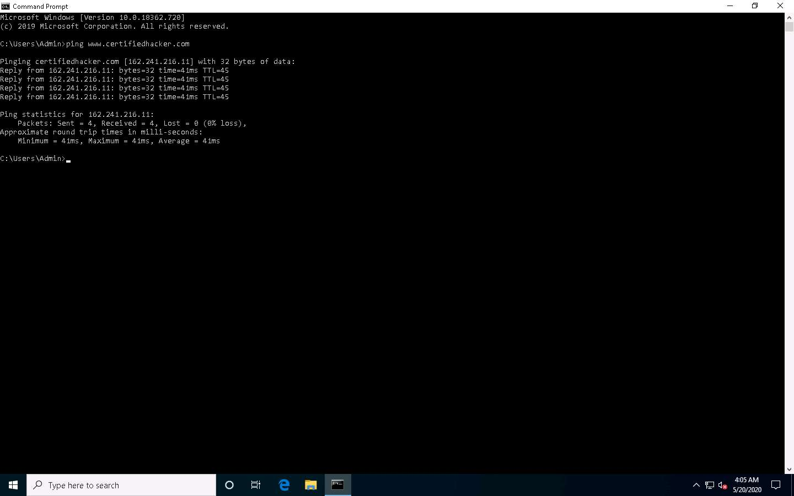

1. Note the target domain’s IP address in the result above (here, **162.241.216.11**). You also obtain information on Ping Statistics such as packets sent, packets received, packets lost, and approximate round-trip time.
2. In the **Command Prompt** window, type **ping www.certifiedhacker.com -f -l 1500** and press **Enter**.

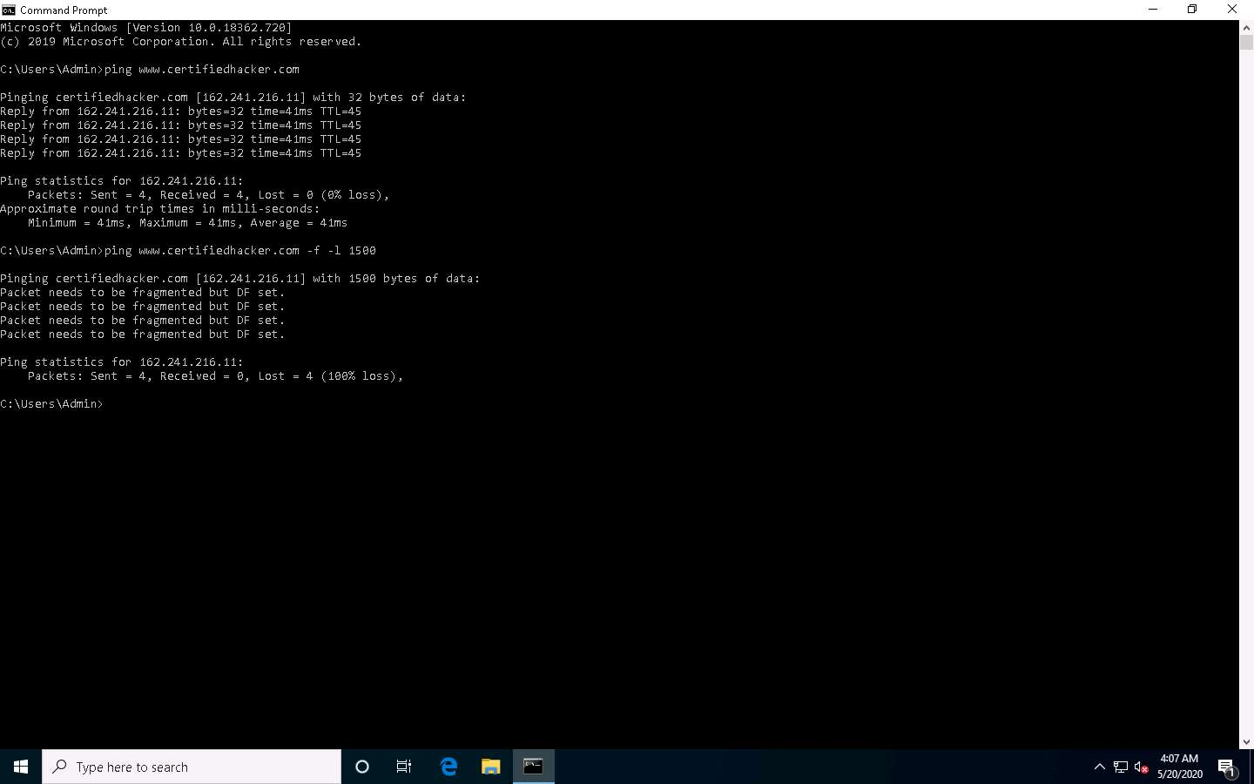

1. The response, **Packet needs to be fragmented but DF set**, means that the frame is too large to be on the network and needs to be fragmented. The packet was not sent as we used the **-f**switch with the ping command, and the ping command returned this error.
2. In the **Command Prompt** window, type **ping www.certifiedhacker.com -f -l 1300** and press **Enter**.

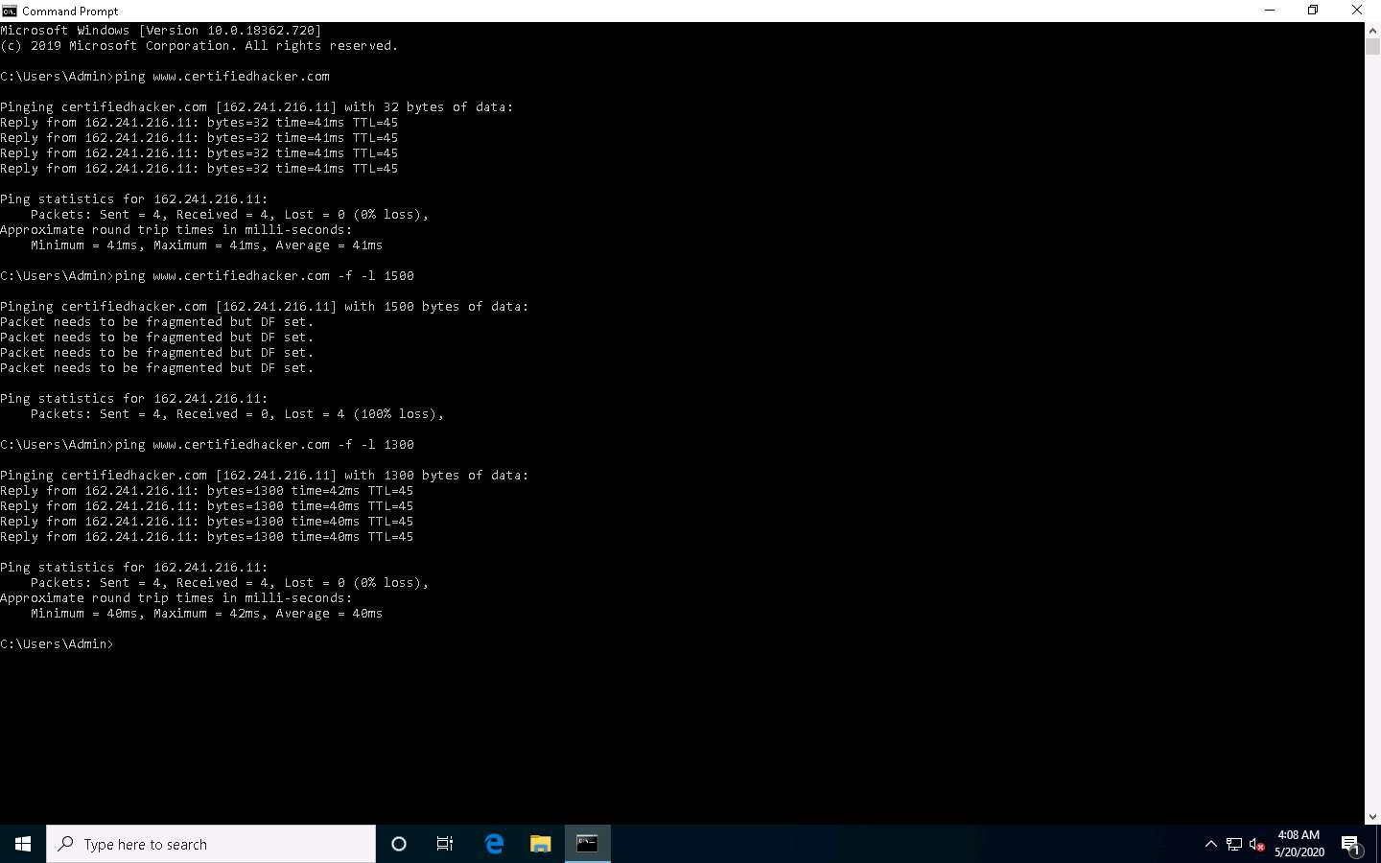

1. Observe that the maximum packet size is less than **1500** bytes and more than **1300** bytes.
2. Now, try different values until you find the maximum frame size. For instance, **ping www.certifiedhacker.com -f -l 1473** replies with **Packet needs to be fragmented but DF set**, and **ping www.certifiedhacker.com -f -l 1472** replies with a successful ping. It indicates that **1472** bytes are the maximum frame size on this machine’s network.

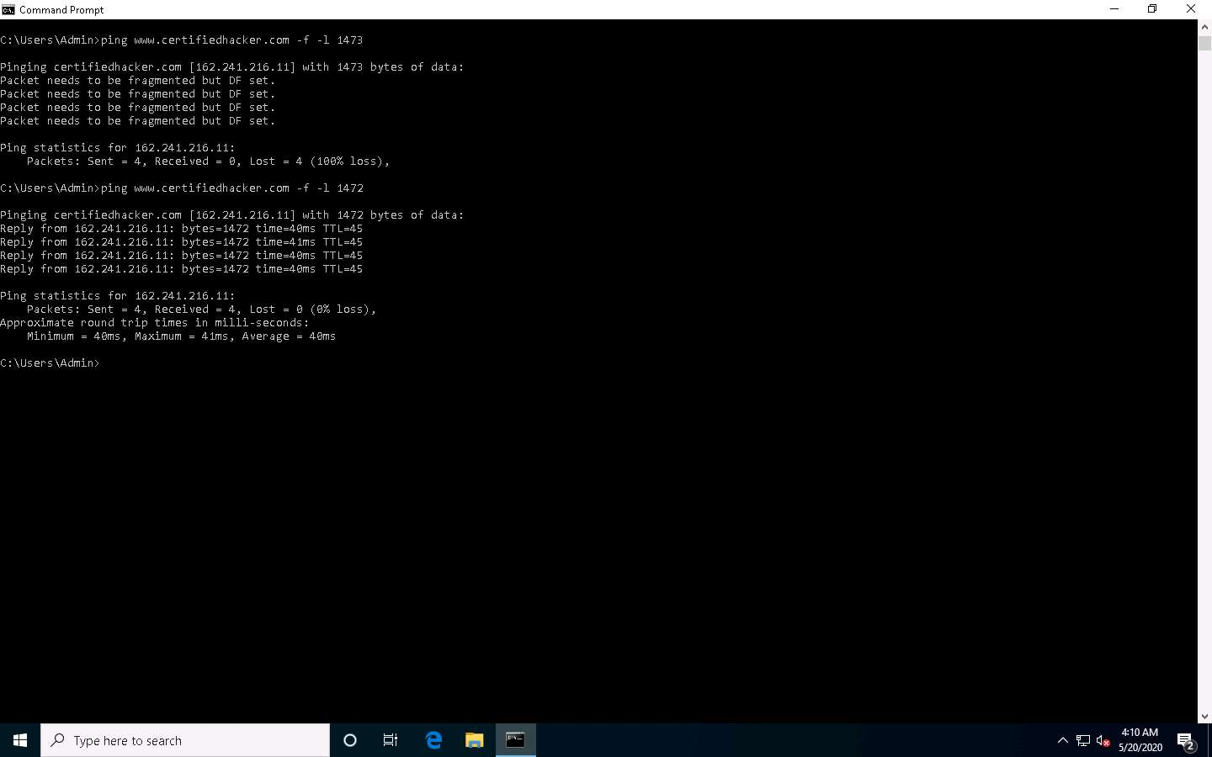

1. Now, discover what happens when TTL (Time to Live) expires. Every frame on the network has TTL defined. If TTL reaches 0, the router discards the packet. This mechanism prevents the loss of packets.
2. In **Command Prompt**, type **ping www.certifiedhacker.com -i 3** and press **Enter**. This option sets the time to live (**-i**) value as **3**.

The maximum value you can set for TTL is 255.

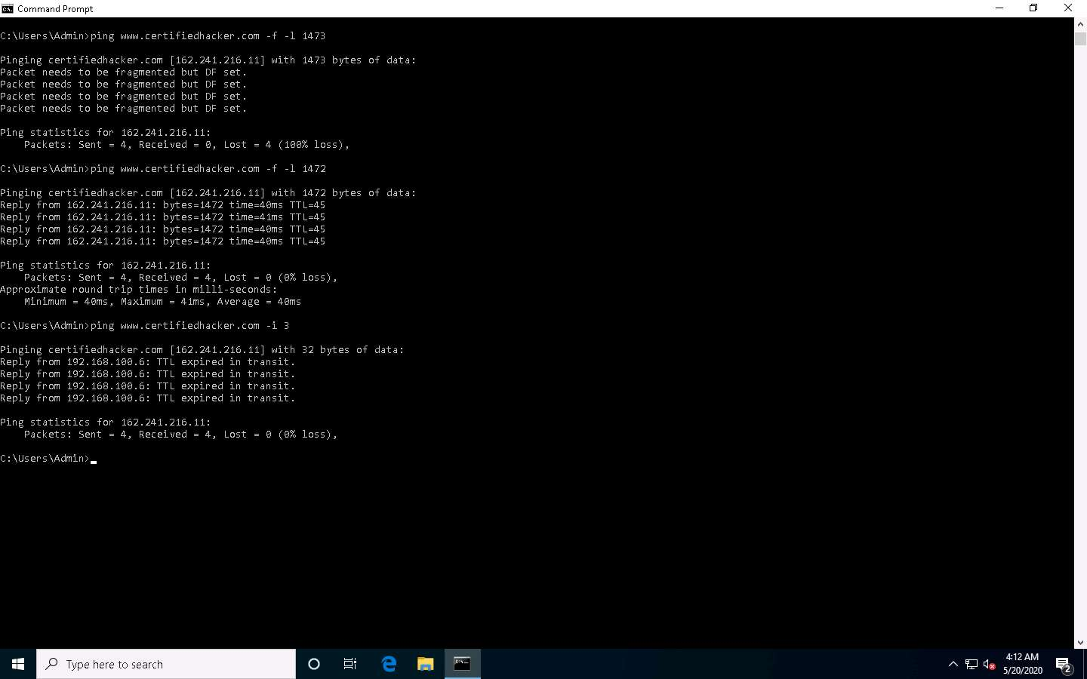

1. Reply from **192.168.100.6**: **TTL expired in transit** means that the router (192.168.100.6, you will have some other IP address) discarded the frame because its TTL has expired (reached 0).

The IP address 192.168.100.6 may vary in your lab environment.

1. Minimize the command prompt shown above and launch a new **command prompt**. Type **ping www.certifiedhacker.com -i 2 -n 1** and press **Enter**. Here, we set the TTL value to **2** and the **-n** value to 1 to check the life span of the packet.

**-n** specifies the number of echo requests to be sent to the target.

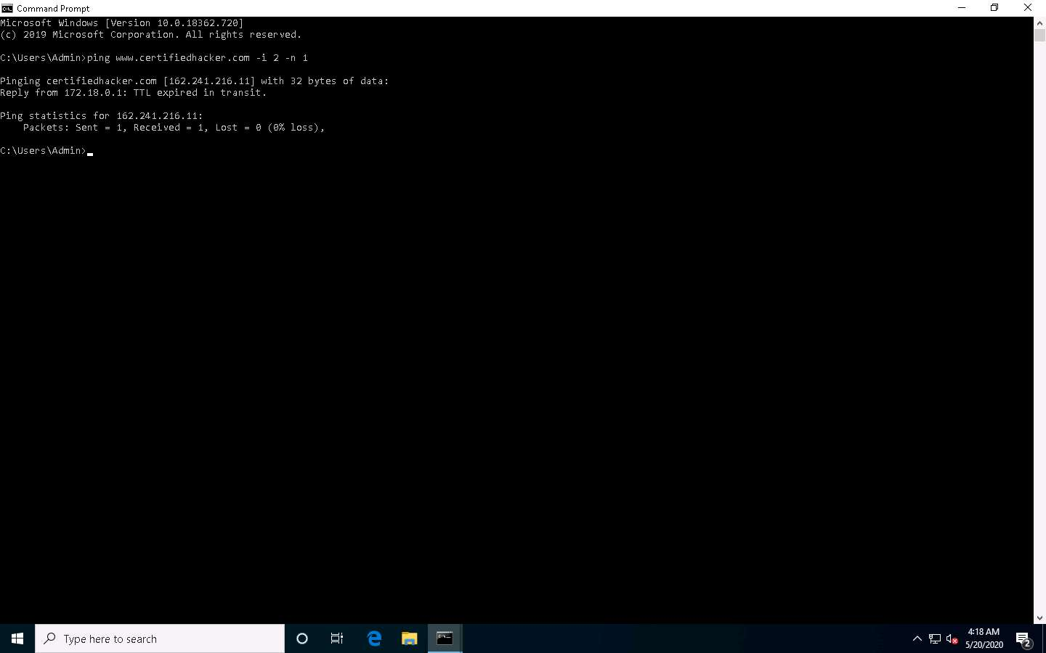

1. Type **ping www.certifiedhacker.com -i 3 -n 1**. This sets the TTL value to **3**.

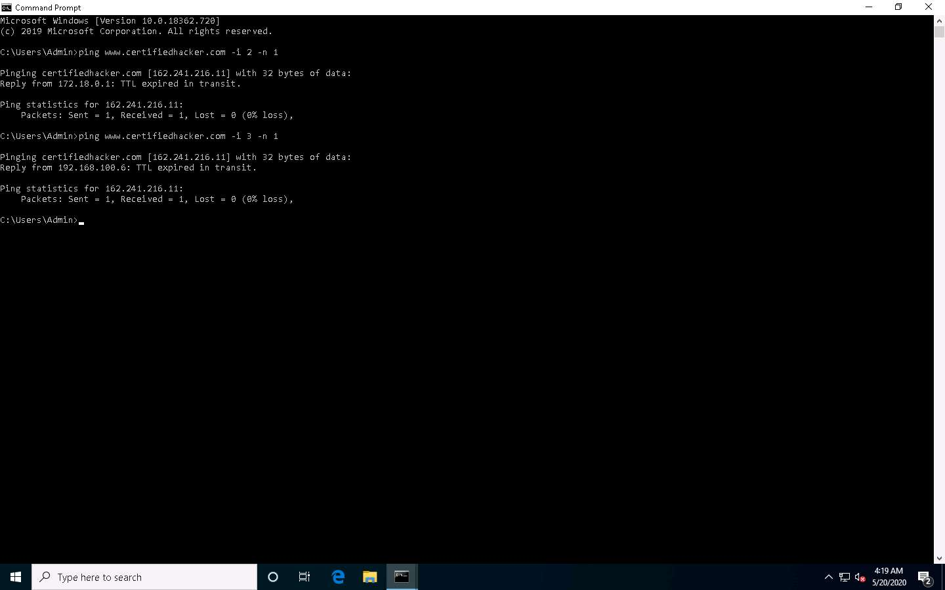

1. Observe that there is a reply coming from the IP address **162.241.216.11**, and there is no packet loss.
2. Now, change the time to live value to **4** by typing, **ping www.certifiedhacker.com -i 4 -n 1** and press **Enter**.

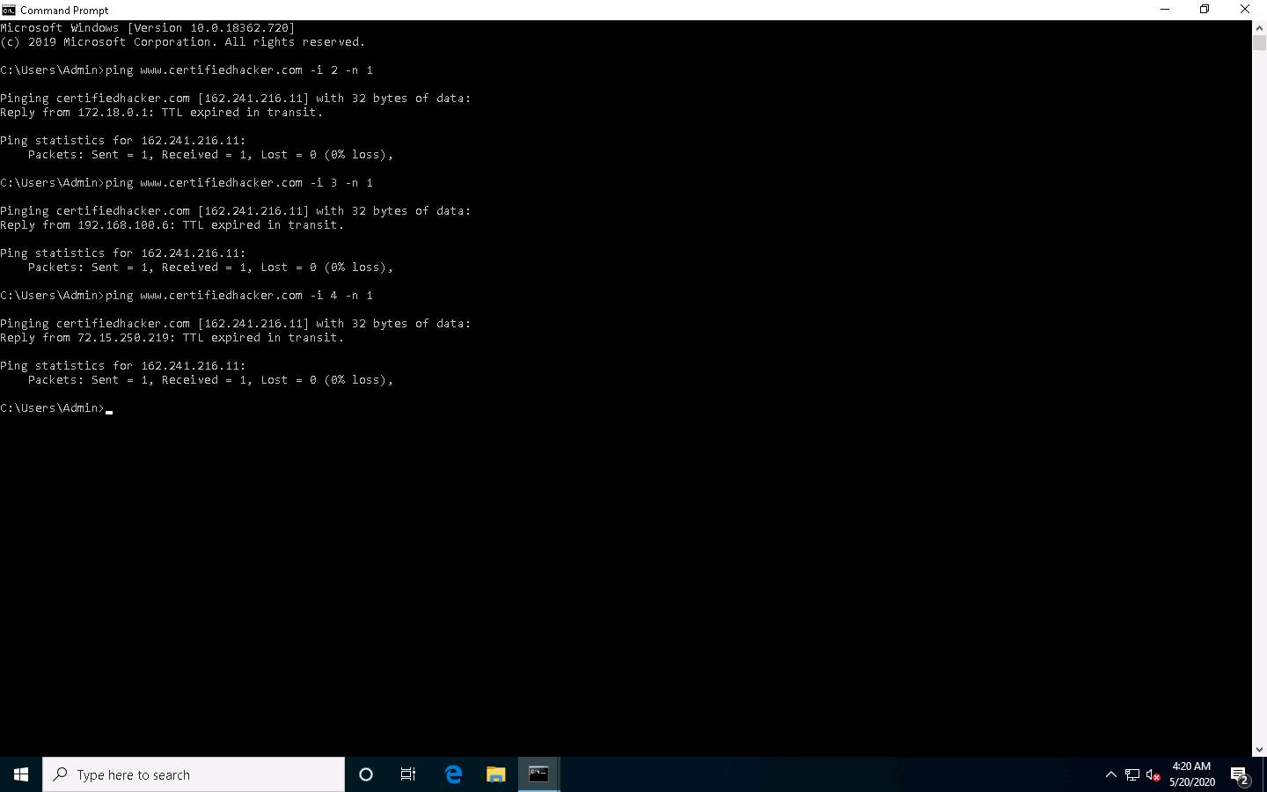

1. Repeat the above step until you reach the IP address for **www.certifiedhacker.com** (in this case, **162.241.216.11**).
2. Find the hop value by trying different TTL value to reach www.certifiedhacker.com.
3. On successfully finding the TTL value it will imply that the reply is received from the destination host (**162.241.216.11**).
4. This concludes the demonstration of gathering information about a target website using Ping command-line utility (such as the IP address of the target website, hop count to the target, and value of maximum frame size allowed on the target network).
5. Close all open windows and document all the acquired information.

Task 2: Gather Information About a Target Website using Central Ops

CentralOps (centralops.net) is a free online network scanner that investigates domains and IP addresses, DNS records, traceroute, nslookup, whois searches, etc.

1. Open any web browser (here, **Mozilla Firefox**). In the address bar of the browser place your mouse cursor, click https://centralops.net and press **Enter**. The Central Ops website appears, as shown in the screenshot.

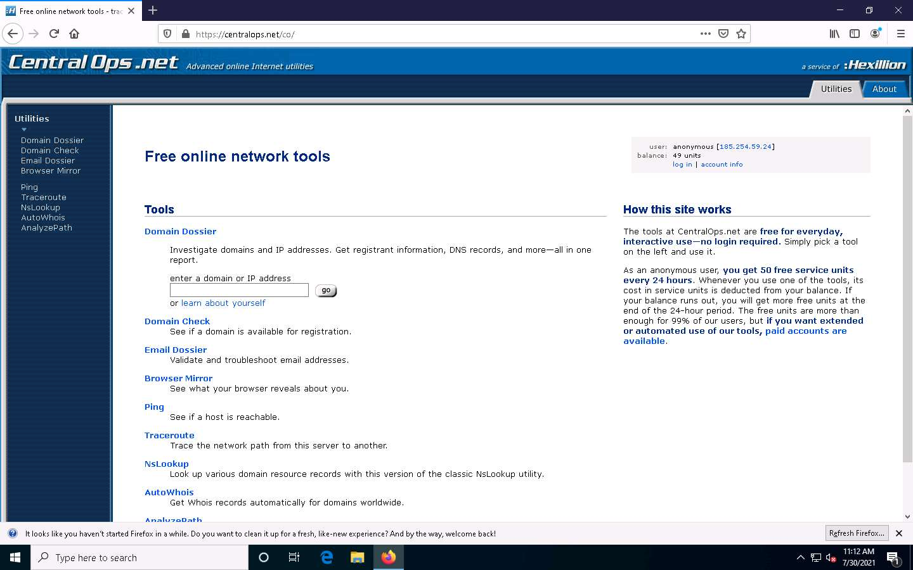

1. To extract information associated with the target organization website, type the target website’s URL (here, **www.certifiedhacker.com**) in the **enter a domain or IP address** field, and then click on the **go** button, as shown in the screenshot below.

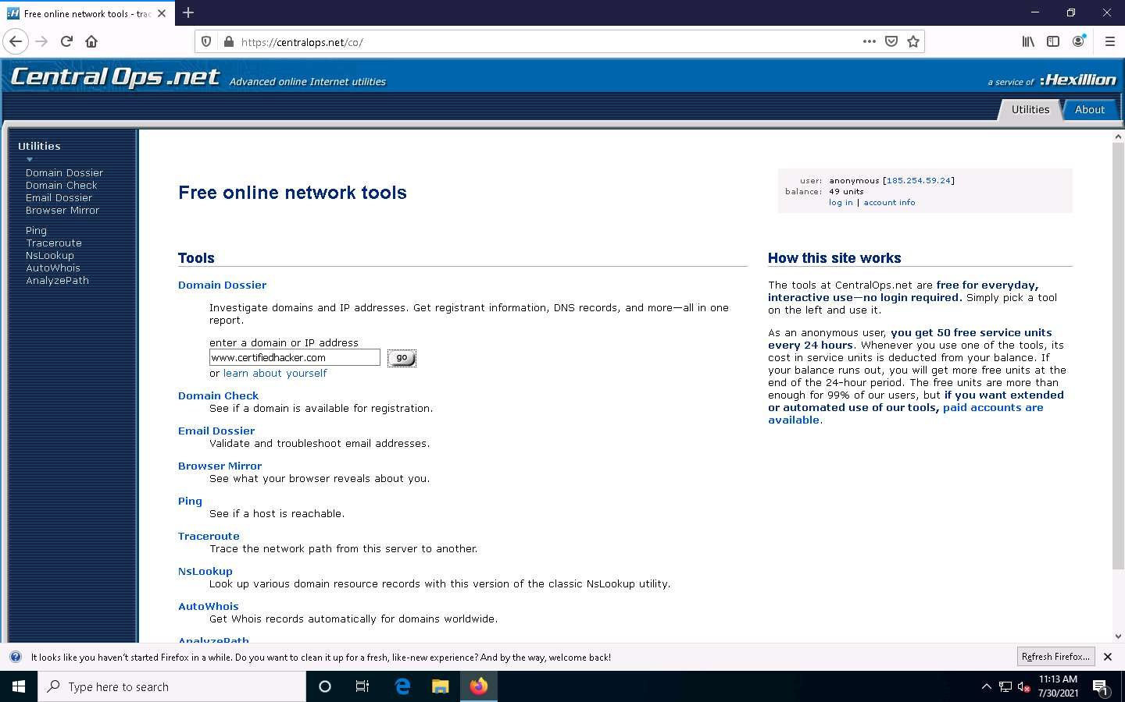

1. A search result for **WWW.CERTIFIEDHACKER.COM** containing information such as **Address lookup**, **Domain Whois record**, as shown in the screenshot.

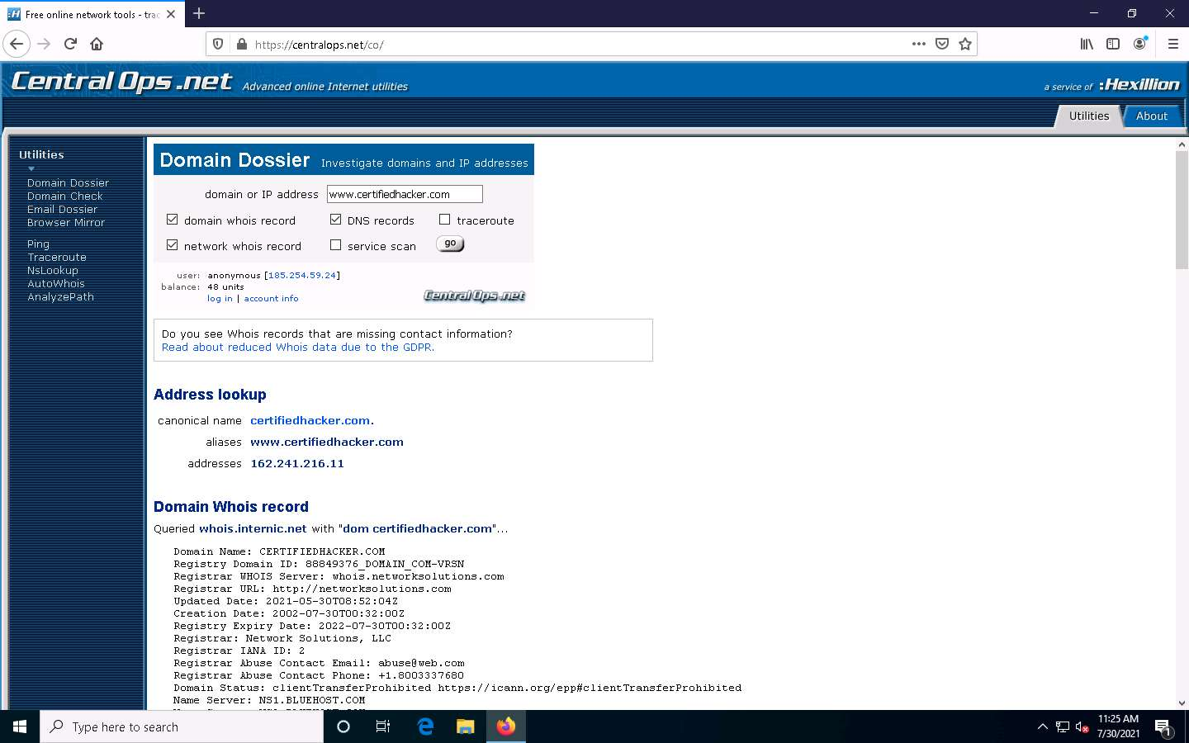

1. Scroll-down to view information such as **Network Whois record** and **DNS records**, as shown in the screenshots.

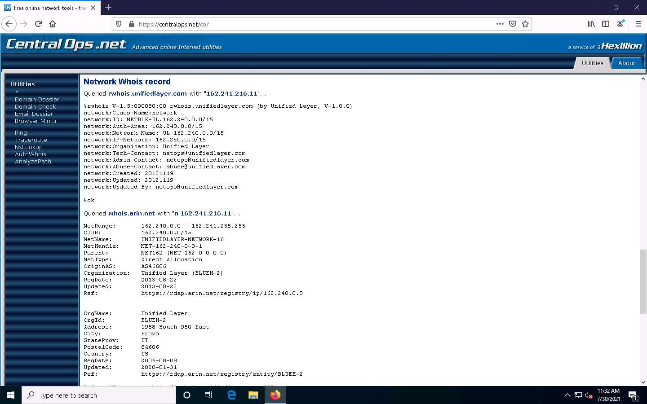

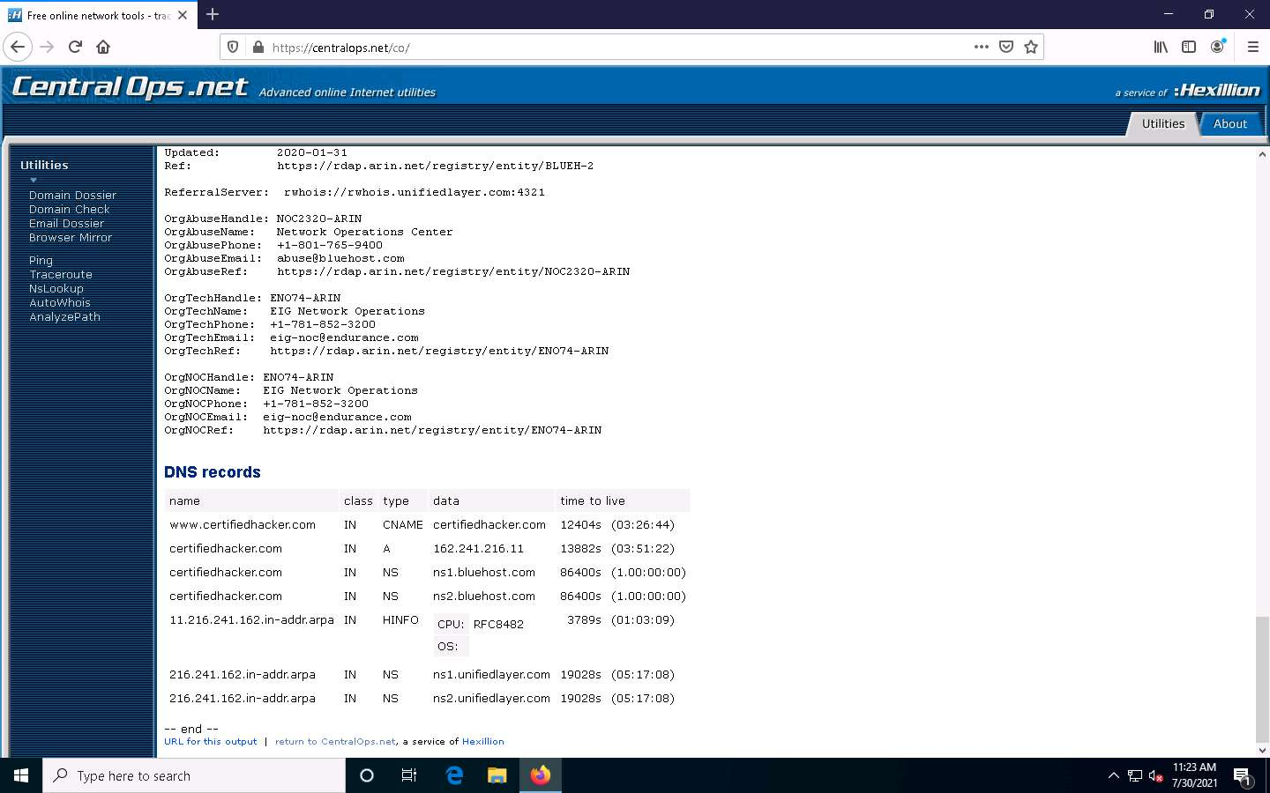

1. This concludes the demonstration of gathering information about a target website using the Central Ops online tool.
2. You can also use tools such as **Website Informer** (https://website.informer.com), **Burp Suite** (https://portswigger.net), **Zaproxy** (https://www.owasp.org), etc. to perform website footprinting on a target website.
3. Close all open windows and document all the acquired information.

Task 3: Extract a Company’s Data using Web Data Extractor

Web data extraction is the process of extracting data from web pages available on the company’s website. A company’s data such as contact details (email, phone, and fax), URLs, meta tags (title, description, keyword) for website promotion,directories, web research, etc. are important sources of information for an ethical hacker. Web spiders (also known as a web crawler or web robot) such as Web Data Extractor perform automated searches on the target website and extract specified information from the target website.

Here, we will gather the target company’s data using the Web Data Extractor tool.

1. In the **Windows 10** machine, navigate to **D:\CEH-Tools\CEHv11 Module 02 Footprinting and Reconnaissance\Web Spiders\Web Data Extractor** and double-click **wde.exe**.
2. If the **User Account Control** pop-up appears, click **Yes**.
3. Follow the wizard steps to install Web Data Extractor and click **Finish**.

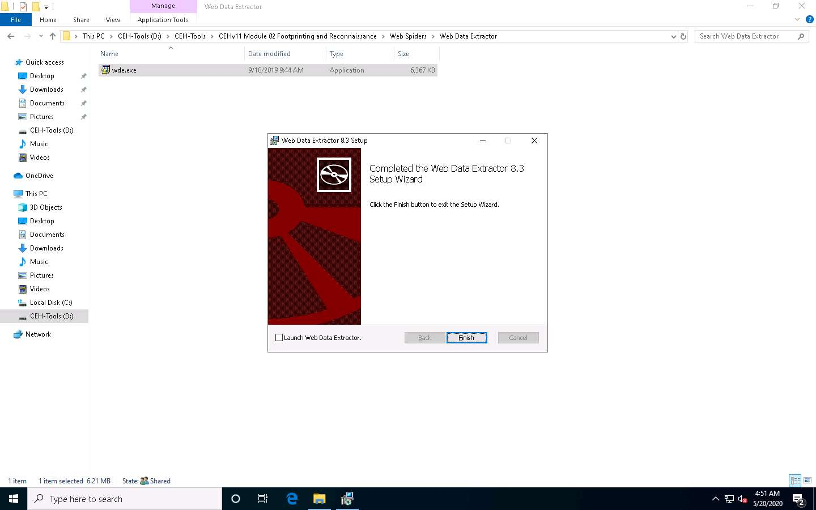

1. After installation, launch **Web Data Extractor** from **Desktop**.



1. The **Web Data Extractor** main window appears. Click **New** to start a new session.

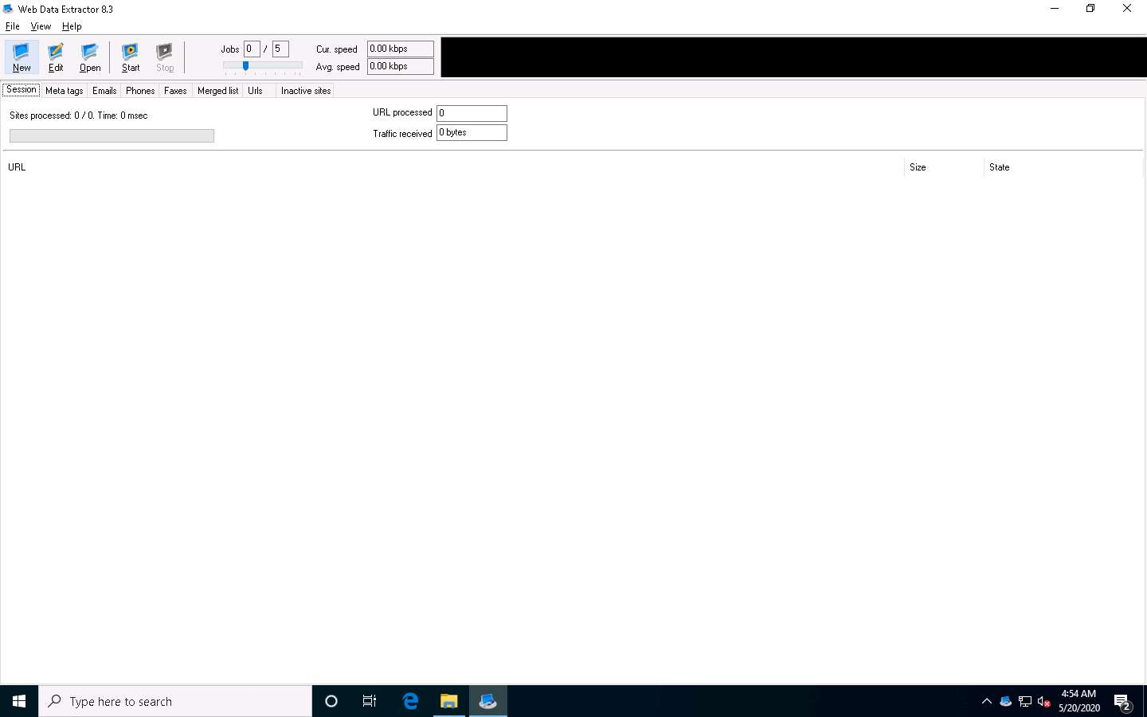

1. The **Session settings** window appears; type a URL (here, **http://www.certifiedhacker.com**) in the **Starting URL** field. Check all the options, as shown in the screenshot, and click **OK**.

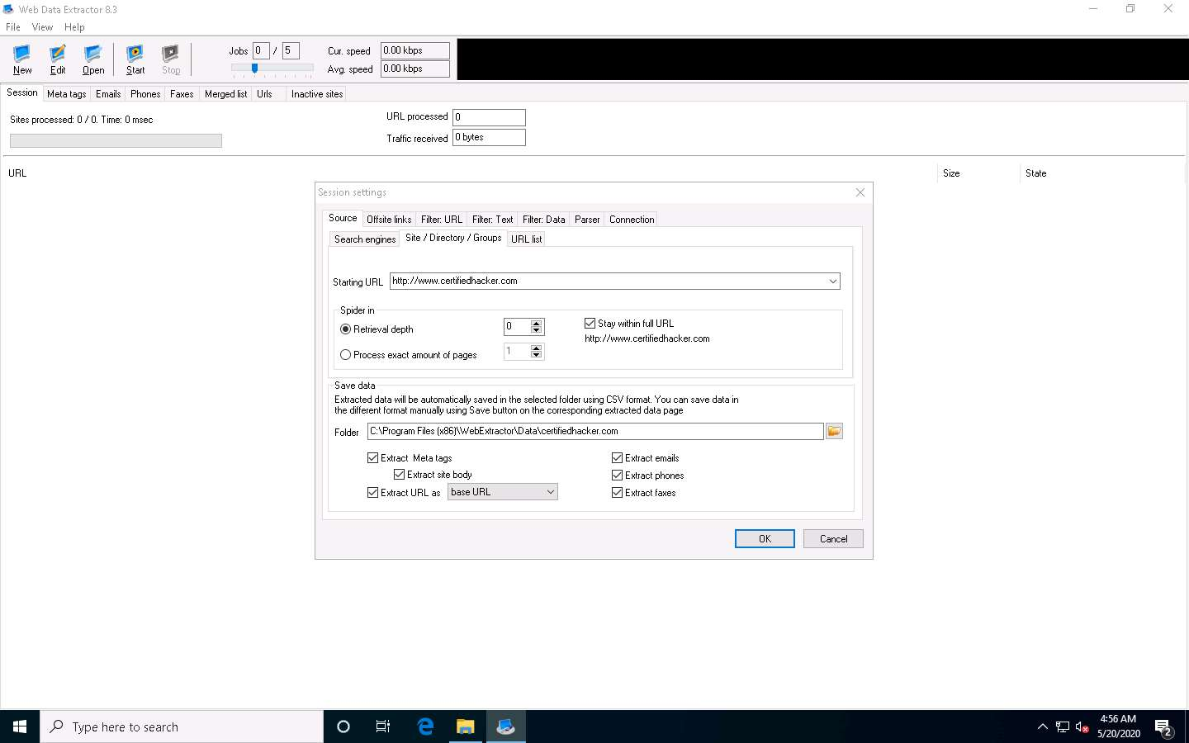

1. Click **Start** to initiate the data extraction.

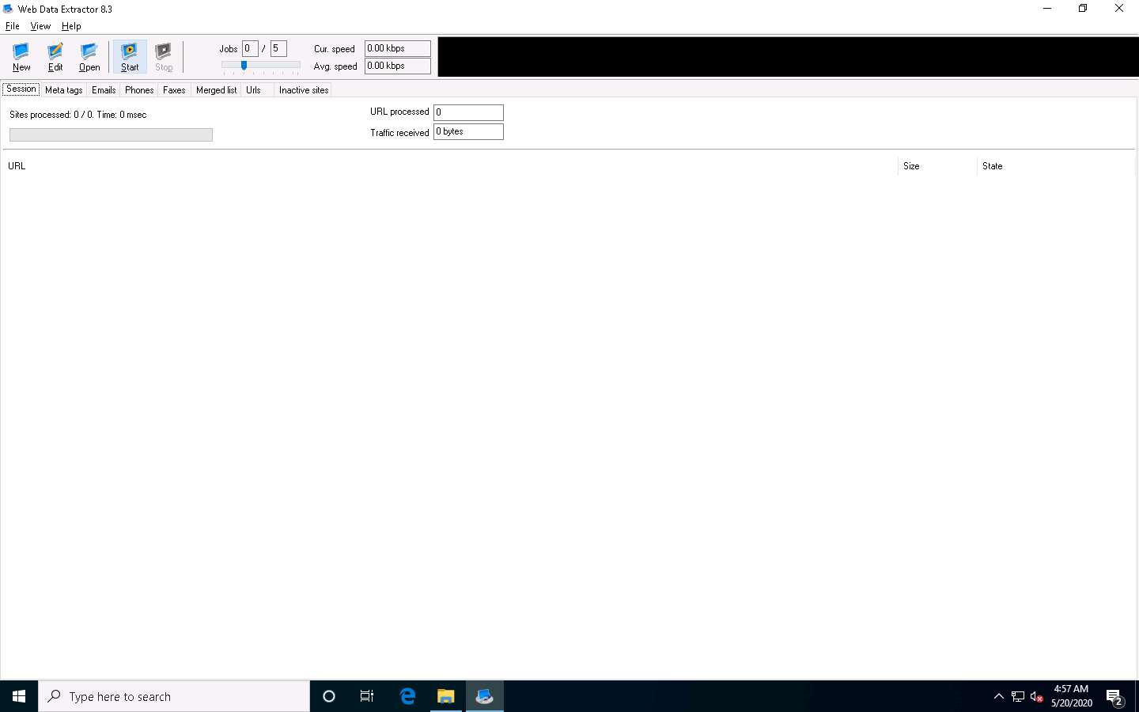

1. **Web Data Extractor** will start collecting information (**Session**, **Meta tags**, **Emails**, **Phones**, **Faxes**, **Merged list**, **URLs**, and **Inactive sites**).

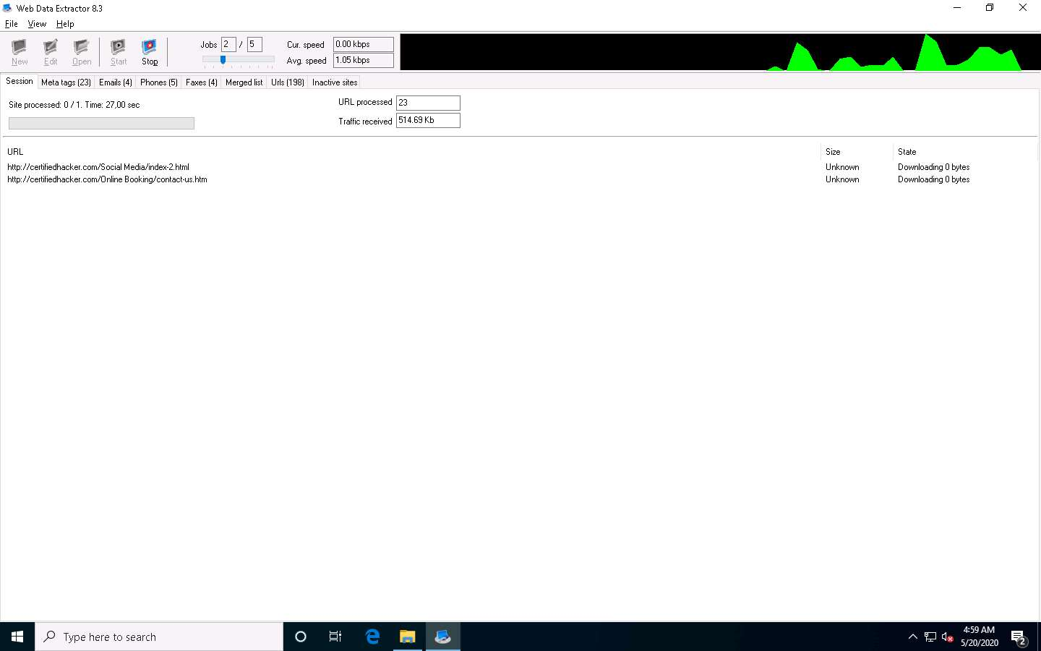

1. Once the data extraction process is completed, an **Information** dialog box appears; click **OK**.

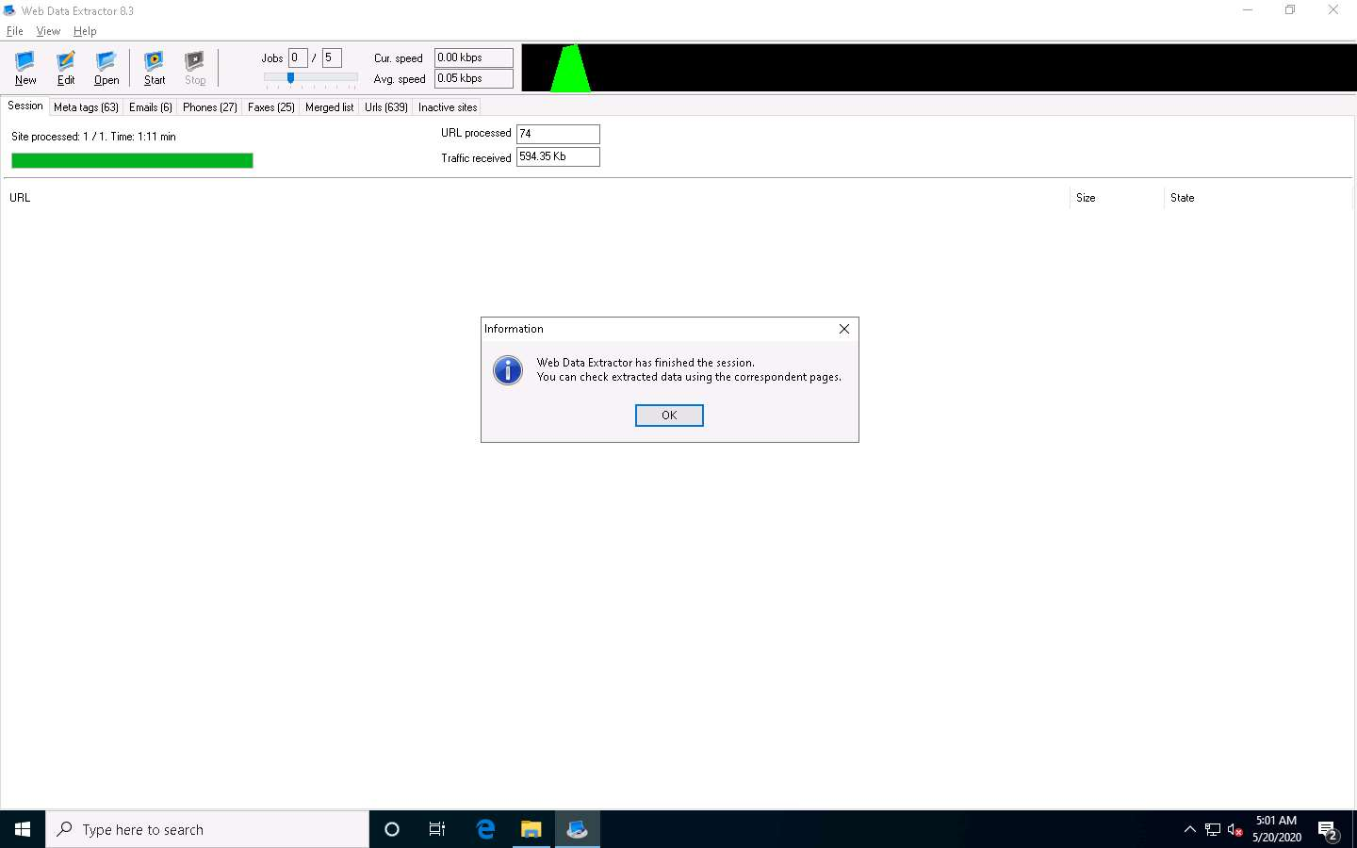

1. View the extracted information by clicking the tabs.
2. Select the **Meta tags** tab to view the URL, Title, Keywords, Description, Host, Domain, page size, etc.

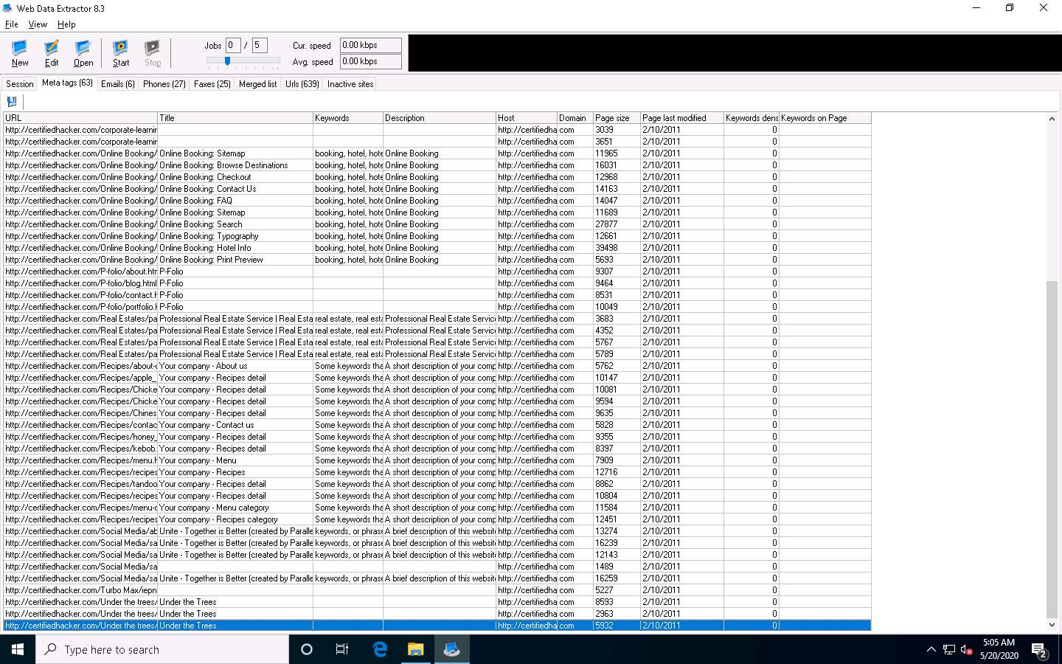

1. Select the **Emails** tab to view information related to emails such as Email address, Name, URL, Title, etc.

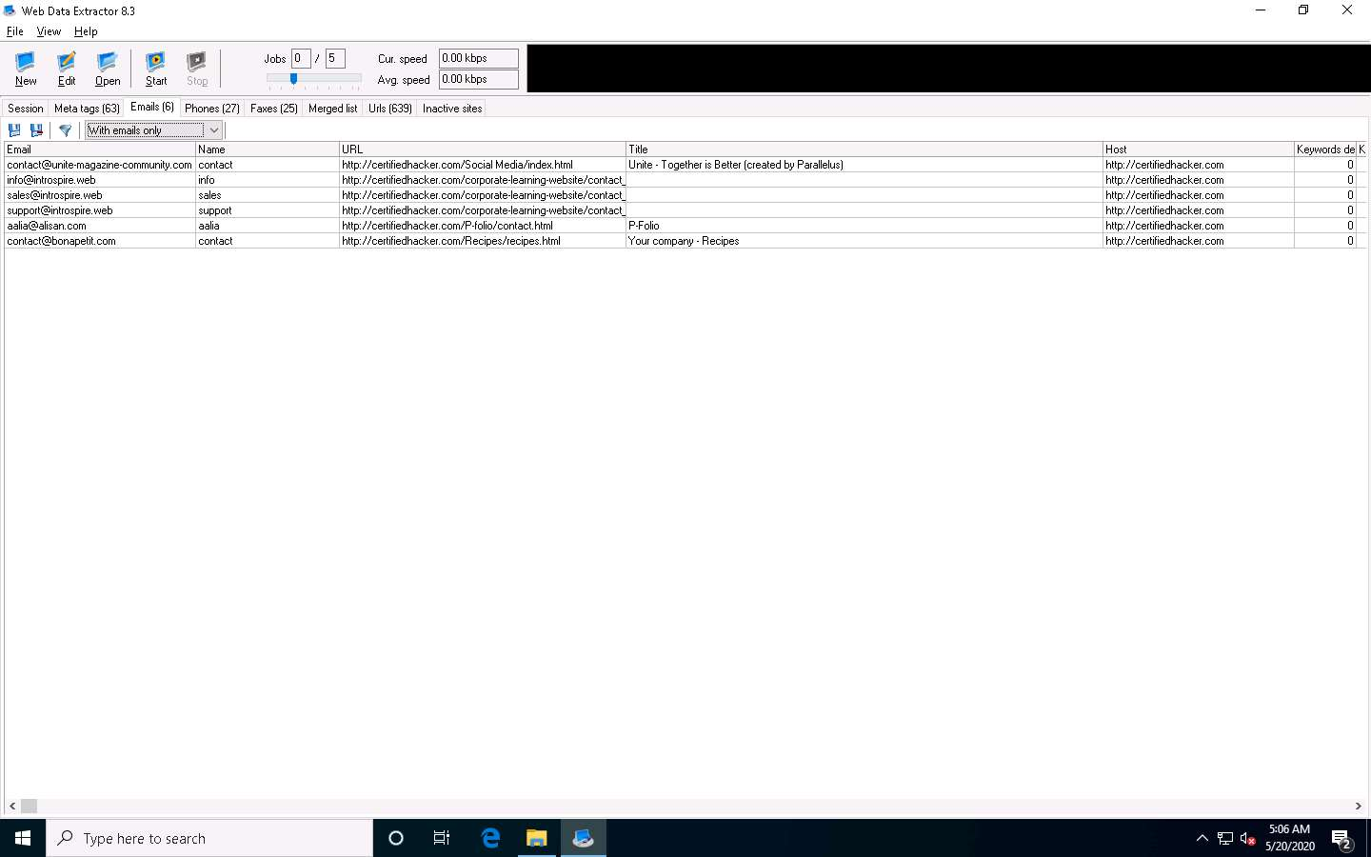

1. Select the **Phones** tab to view the Phone, Source, Tag, URL, etc.

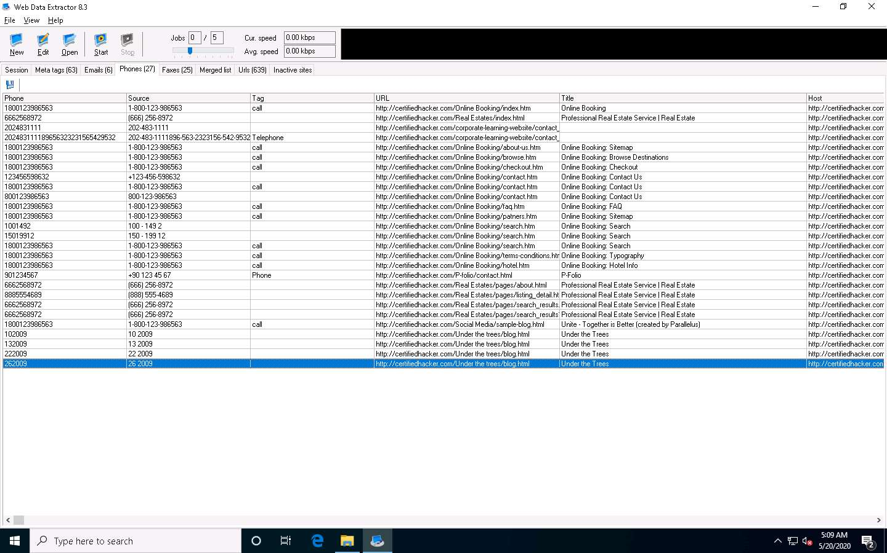

1. Check for more information under the **Faxes**, **Merged list**, **URLs**, and **Inactive sites** tabs.
2. To save the session, choose **File** and click **Save session**.

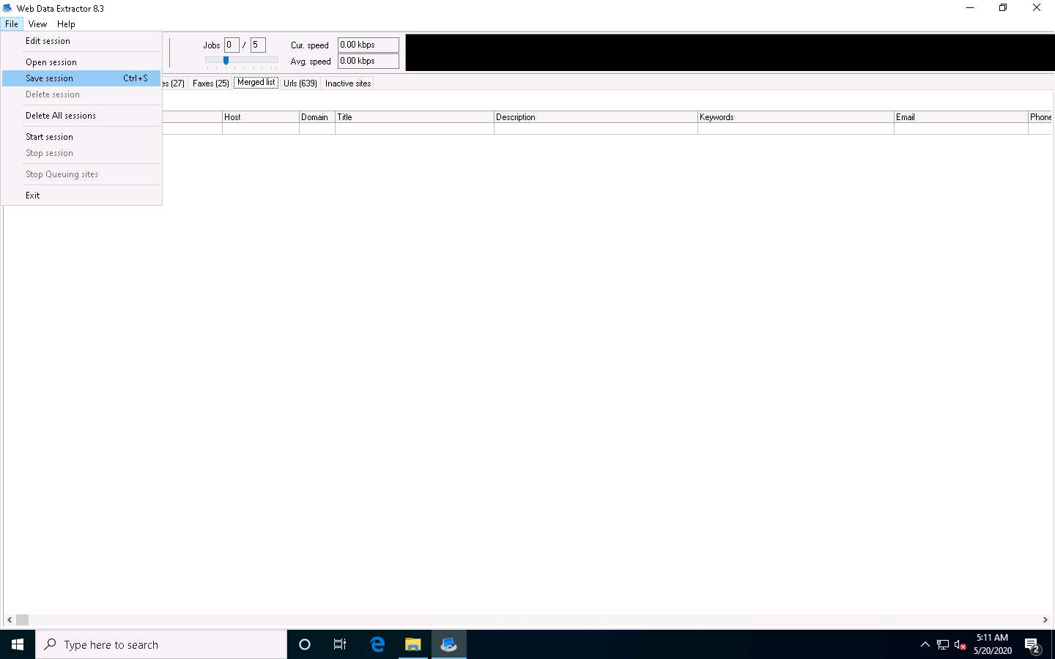

1. Specify the session name (here, **certifiedhacker.com**) in the **Save session** dialog box and click **OK**.

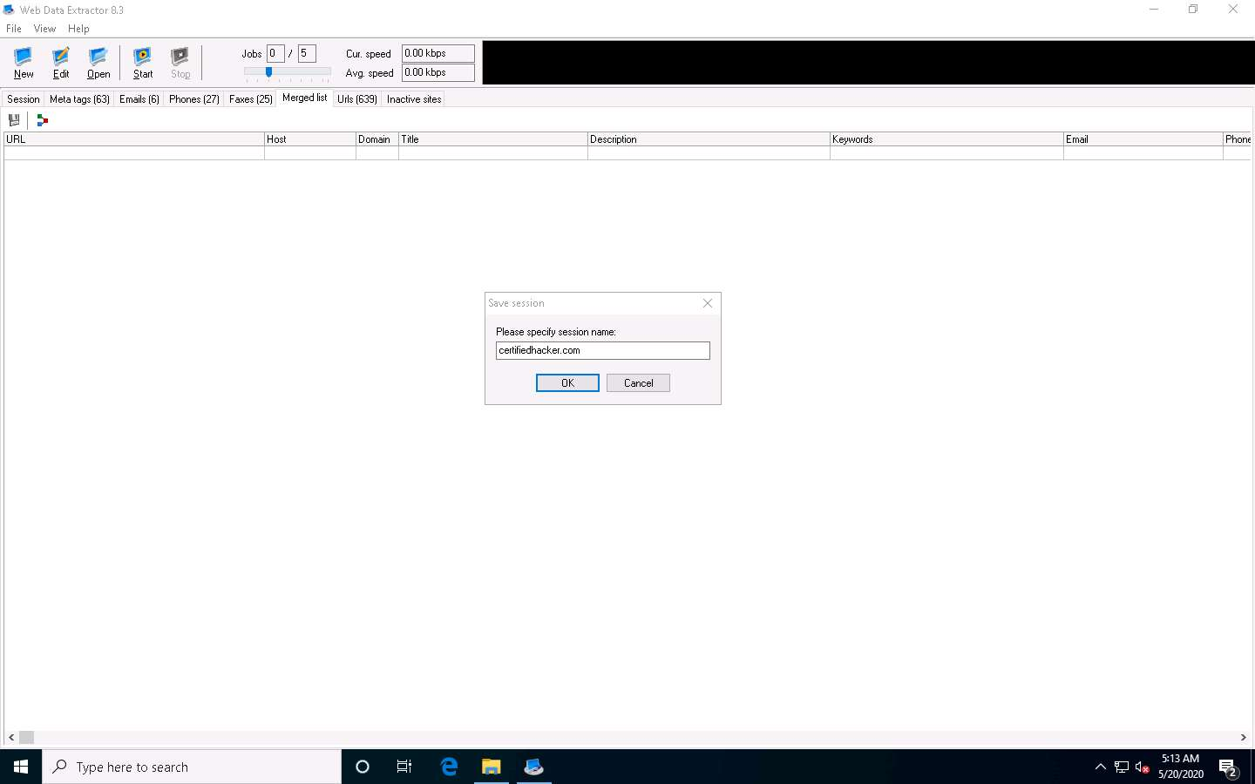

1. Click the **Meta tags** tab, and then click the **floppy** icon.

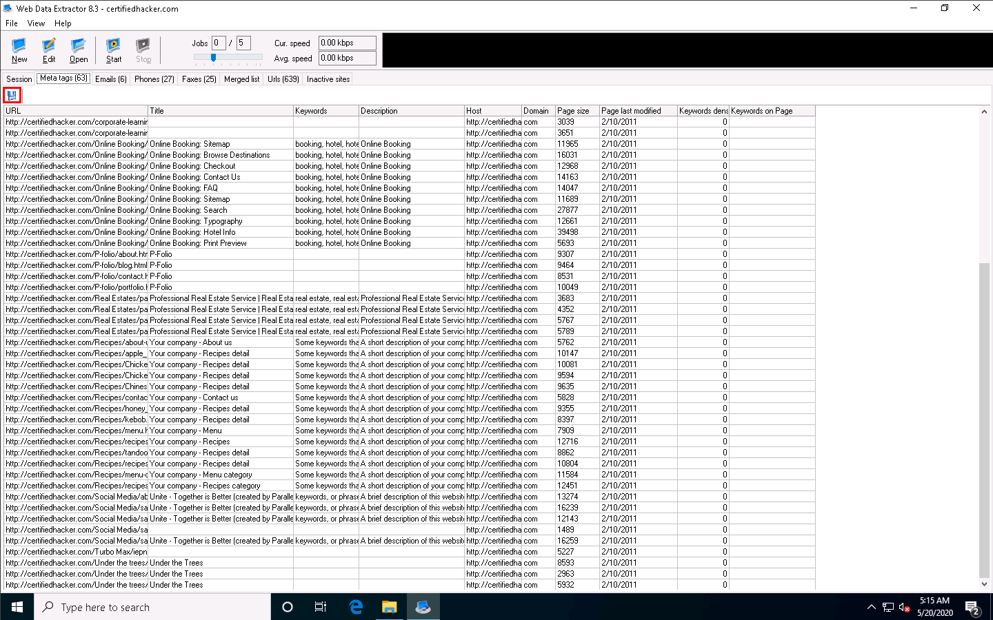

1. An **Information** pop-up may appear with the message **You cannot save more than 10 records in Demo Version**; click **OK**.
2. The **Save Meta tags** window appears. In the **File name** field, click on the **folder icon**, select the location where you want to save the file, choose **File format**, and click **Save**.

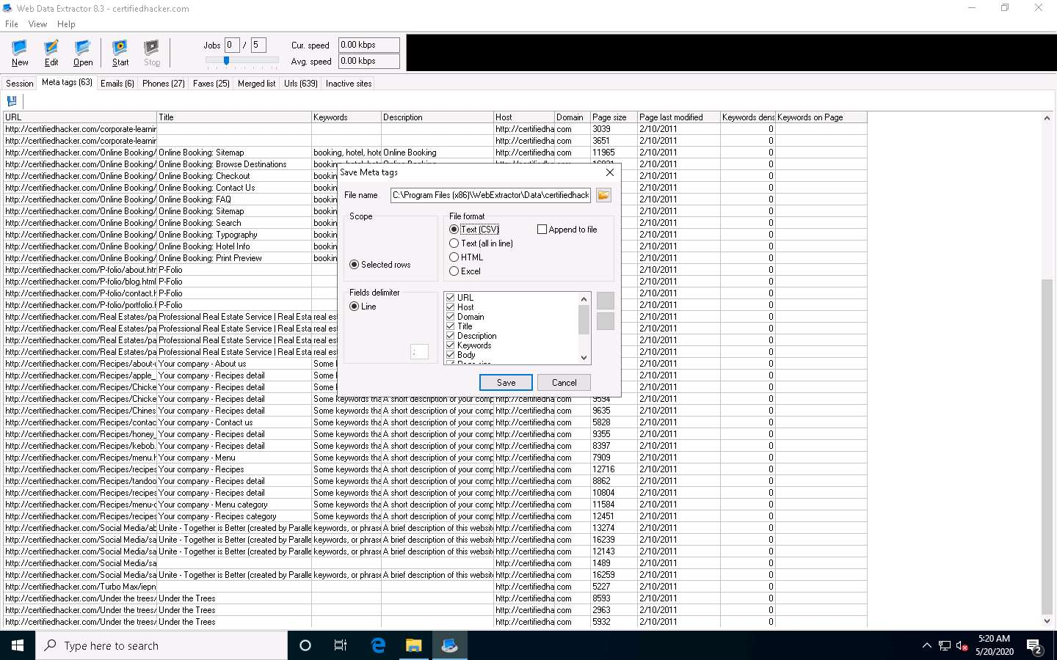

1. By default, the session will be saved at **C:\Program Files (x86)\WebExtractor\Data\certifiedhacker.com**. You can choose your desired location to save the file.
2. This concludes the demonstration of extracting a company’s data using the Web Data Extractor tool.
3. You can also use other web spiders such as **ParseHub** (https://www.parsehub.com), **SpiderFoot** (https://www.spiderfoot.net), etc. to extract the target organization’s data.
4. Close all open windows and document all the acquired information.

Task 4: Mirror a Target Website using HTTrack Web Site Copier

Website mirroring is the process of creating a replica or clone of the original website; this mirroring of the website helps you to footprint the web site thoroughly on your local system, and allows you to download a website to a local directory, analyze all directories, HTML, images, flash, videos, and other files from the server on your computer.

You can duplicate websites by using website mirroring tools such as HTTrack Web Site Copier. HTTrack is an offline browser utility that downloads a website from the Internet to a local directory, builds all directories recursively, and transfers HTML, images, and other files from the webserver to another computer.

Here, we will use the HTTrack Web Site Copier tool to mirror the entire website of the target organization, store it in the local system drive, and browse the local website to identify possible exploits and vulnerabilities.

1. In the **Windows 10** machine, navigate to **D:\CEH-Tools\CEHv11 Module 02 Footprinting and Reconnaissance\Website Mirroring Tools\HTTrack Web Site Copier** and double-click **httrack-3.49.2.exe**.
2. If the **User Account Control** pop-up appears, click **Yes**.
3. Follow the wizard steps to install **HTTrack Web Site Copier**.
4. In the last step of the installation wizard, uncheck the **View history.txt file** option and click **Finish**.

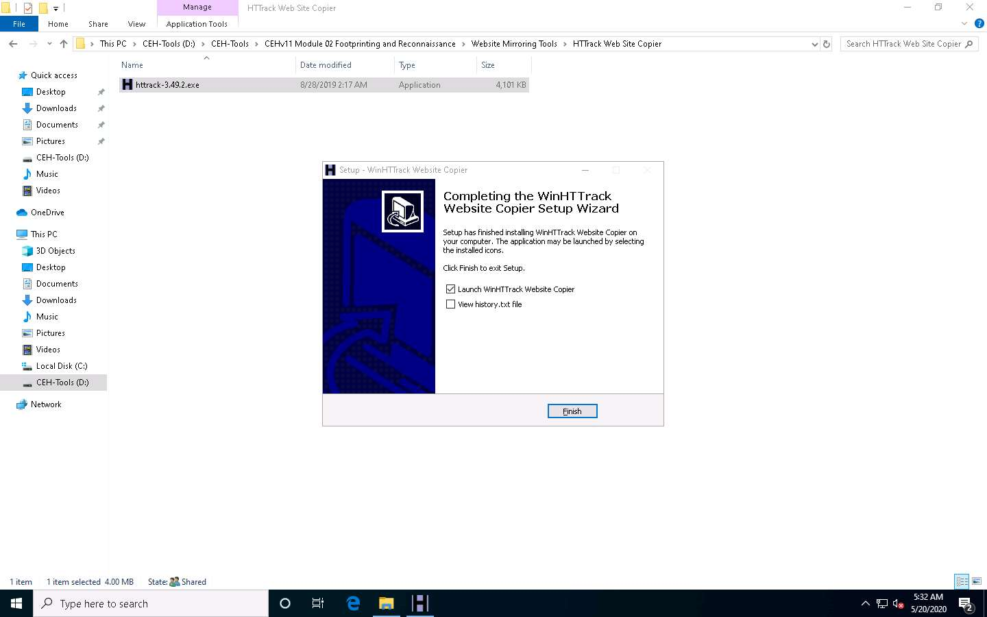

1. The **WinHTTrack Website Copier** window appears. Click **OK** in the pop-up window, and then click **Next >** to create a **New Project**.

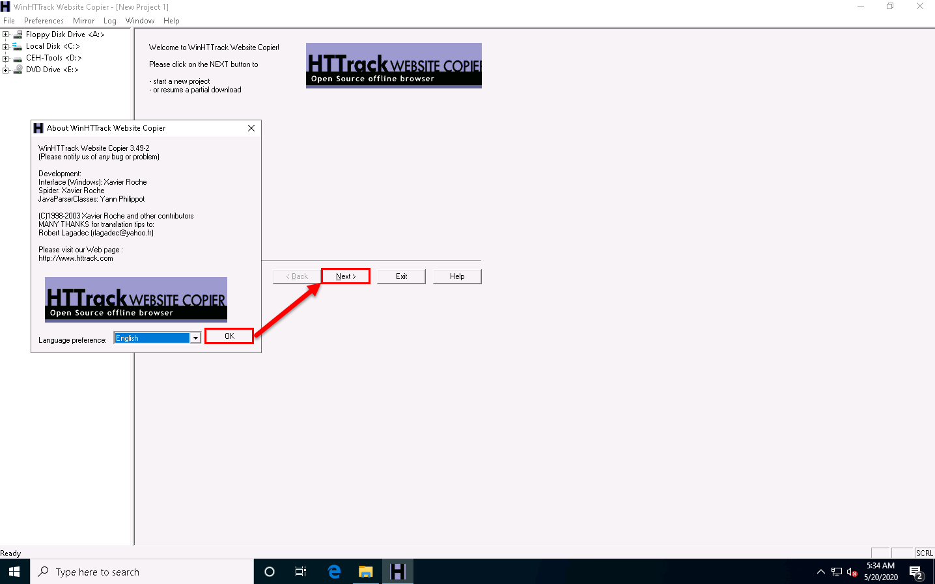

1. Enter the name of the project (here, **Test Project**) in the **New project name:** field. Select the **Base path:** to store the copied files; click **Next >**.

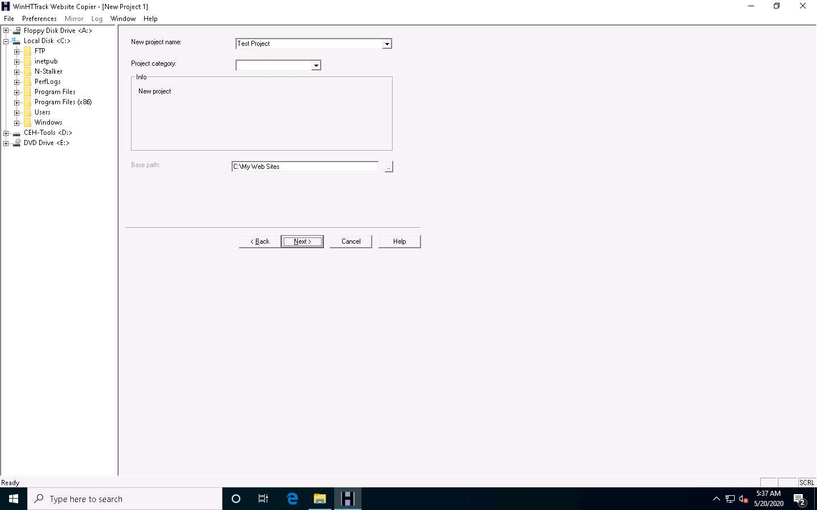

1. Enter a target URL (here, **www.certifiedhacker.com**) in the **Web Addresses: (URL)** field and click **Set options…**.

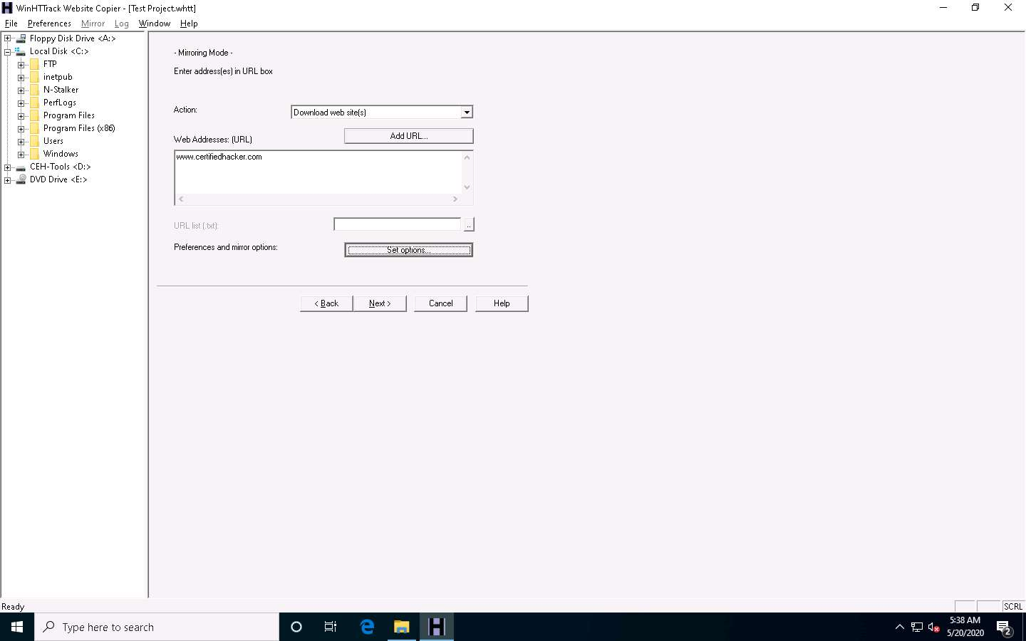

1. **WinHTTrack** window appears, click the **Scan Rules** tab and select the checkboxes for the file types as shown in the following screenshot; click **OK**.

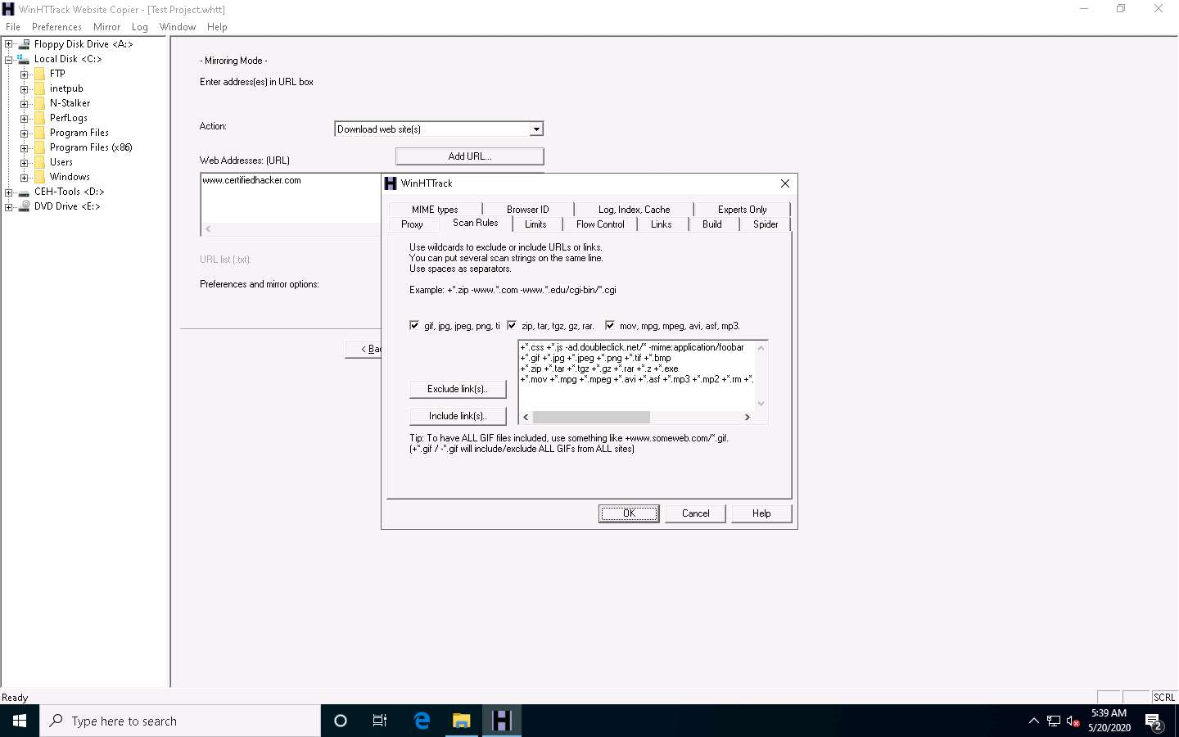

1. Click the **Next >** button.

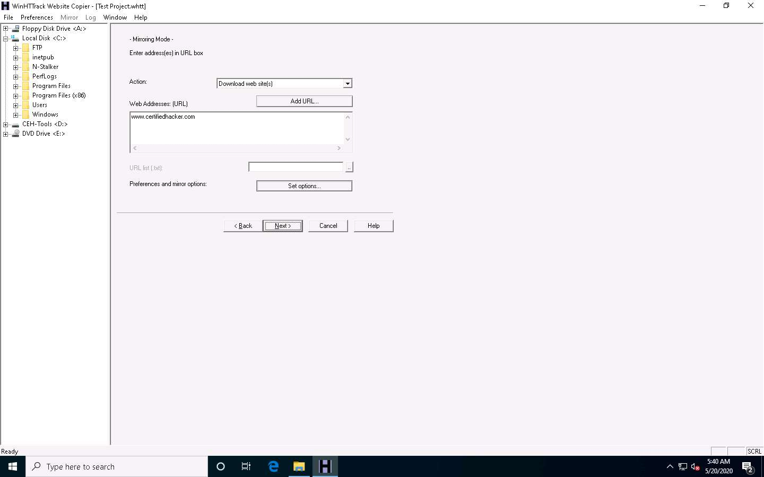

1. By default, the radio button will be selected for **Please adjust connection parameters if necessary, then press FINISH to launch the mirroring operation**. Check **Disconnect when finished** and click **Finish** to start mirroring the website.

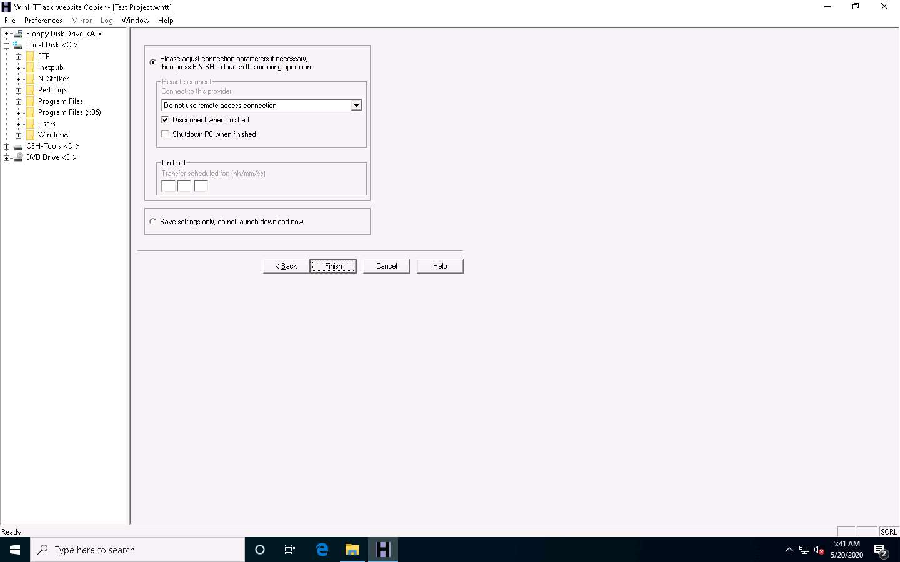

1. Site mirroring progress will be displayed, as shown in the screenshot.

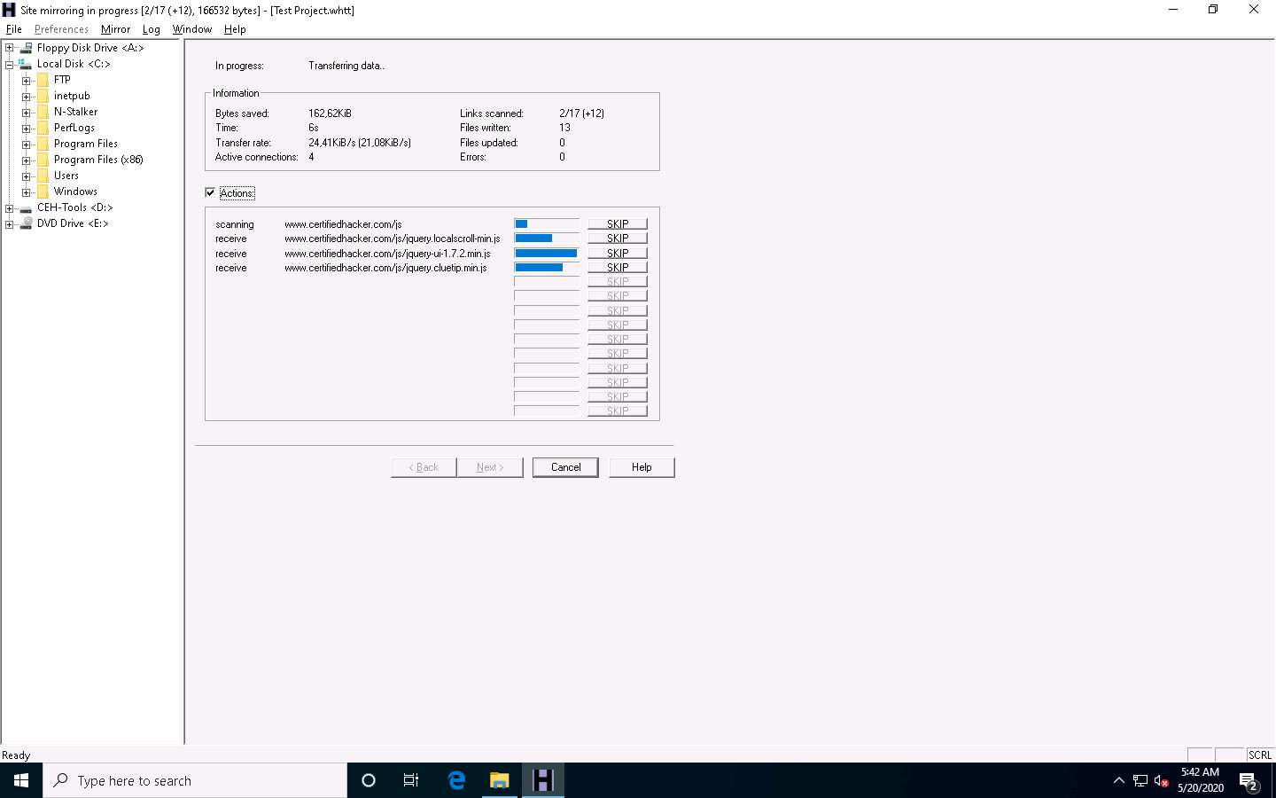

1. Once the site mirroring is completed, WinHTTrack displays the message **Mirroring operation complete**; click on **Browse Mirrored Website**.

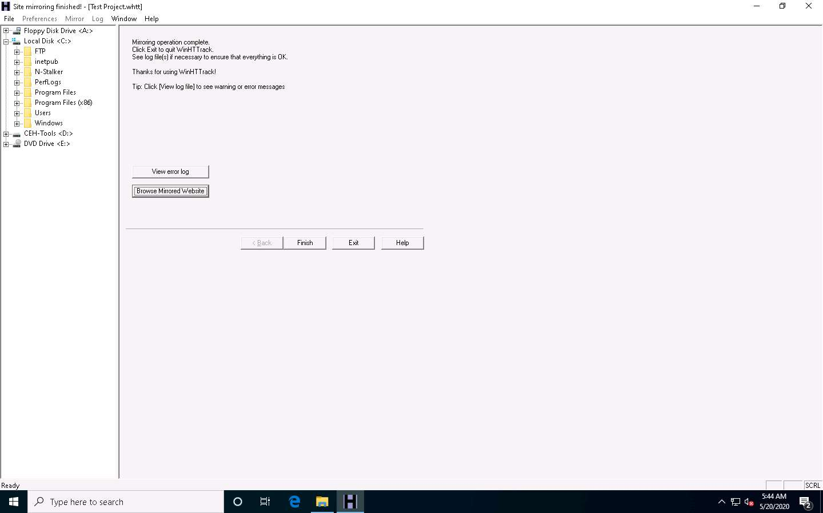

1. If the **How do you want to open this file?** pop up appears, select any web browser and click **OK**.
2. The mirrored website for **www.certifiedhacker.com** launches. The URL displayed in the address bar indicates that the website's image is stored on the local machine.

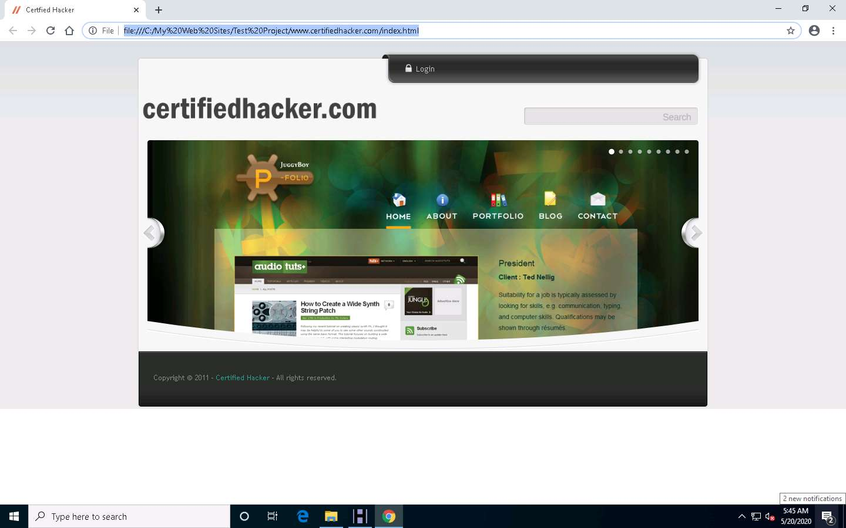

1. Analyze all directories, HTML, images, flash, videos, and other files available on the mirrored target website. You can also check for possible exploits and vulnerabilities. The site will work like a live hosted website.

If the webpage does not open, navigate to the directory where you mirrored the website and open **index.html** with any browser.

1. Once done with your analysis, close the browser window and click **Finish** on the **WinHTTrack** window to complete the process.

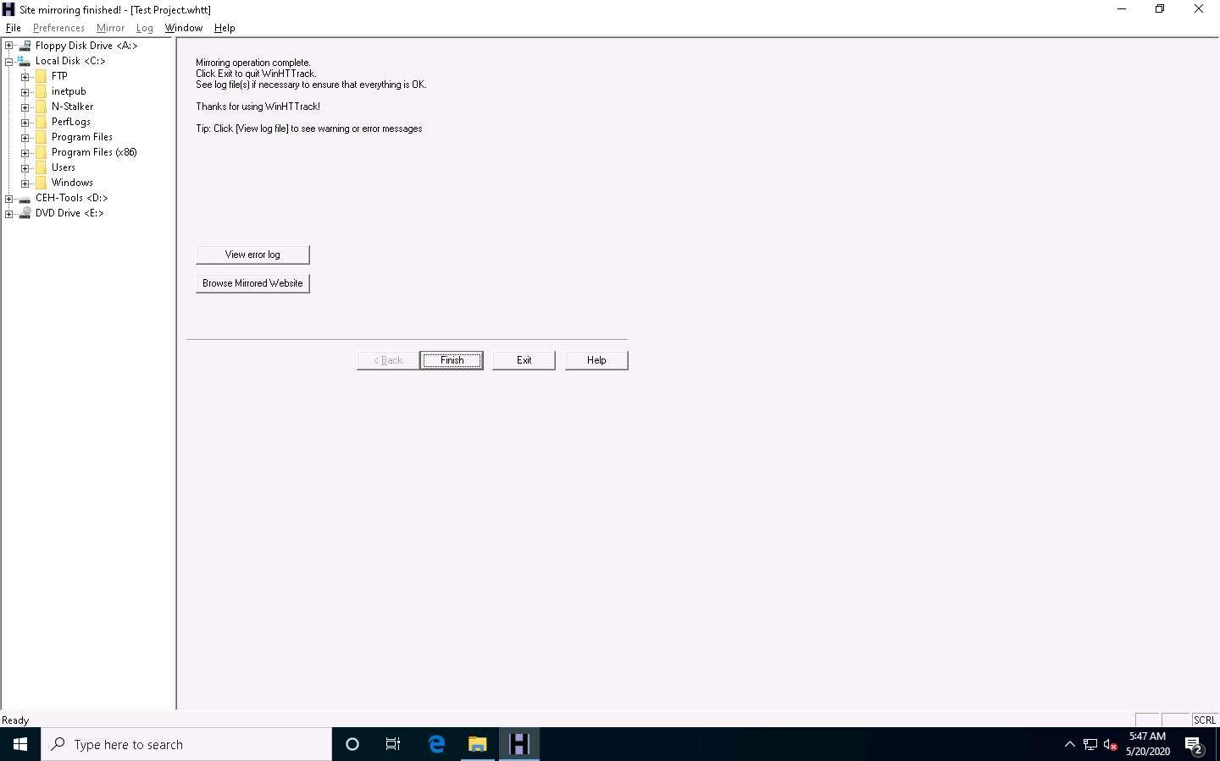

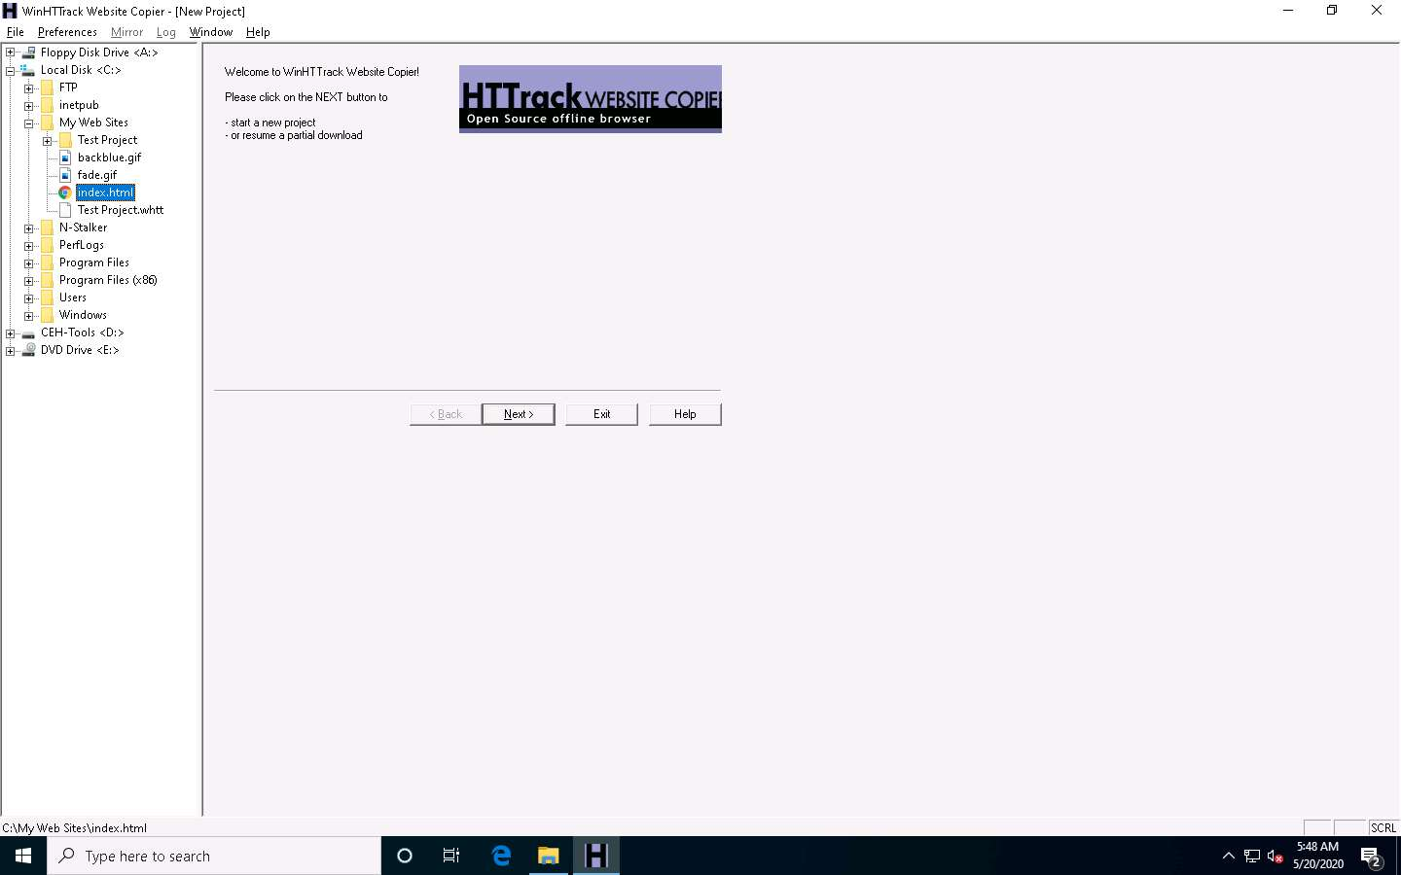

1. Some websites are very large, and it might take a long time to mirror the complete site.
2. This concludes the demonstration of mirroring a target website using HTTrack Web Site Copier.
3. You can also use other mirroring tools such as **NCollector Studio** (http://www.calluna-software.com), **Cyotek WebCopy** (https://www.cyotek.com), etc. to mirror a target website.
4. Close all open windows and document all the acquired information.

Task 5: Gather a Wordlist from the Target Website using CeWL

The words available on the target website may reveal critical information that can assist in performing further exploitation. CeWL is a ruby app that is used to spider a given target URL to a specified depth, optionally following external links, and returns a list of unique words that can be used for cracking passwords.

1. Click [Parrot Security](https://labclient.labondemand.com/Instructions/b16bedc2-7151-47a3-9211-5daccdd8c426?rc=10) to switch to the **Parrot Security** machine.
2. Click the **MATE Terminal** icon at the top-left corner of the **Desktop** window to open a **Terminal** window.



1. A **Parrot Terminal** window appears. In the terminal window, type **sudo su** and press **Enter** to run the programs as a root user.
2. In the **[sudo] password for attacker** field, type **toor** as a password and press **Enter**.

The password that you type will not be visible.

1. Now, type **cd** and press **Enter** to jump to the root directory.

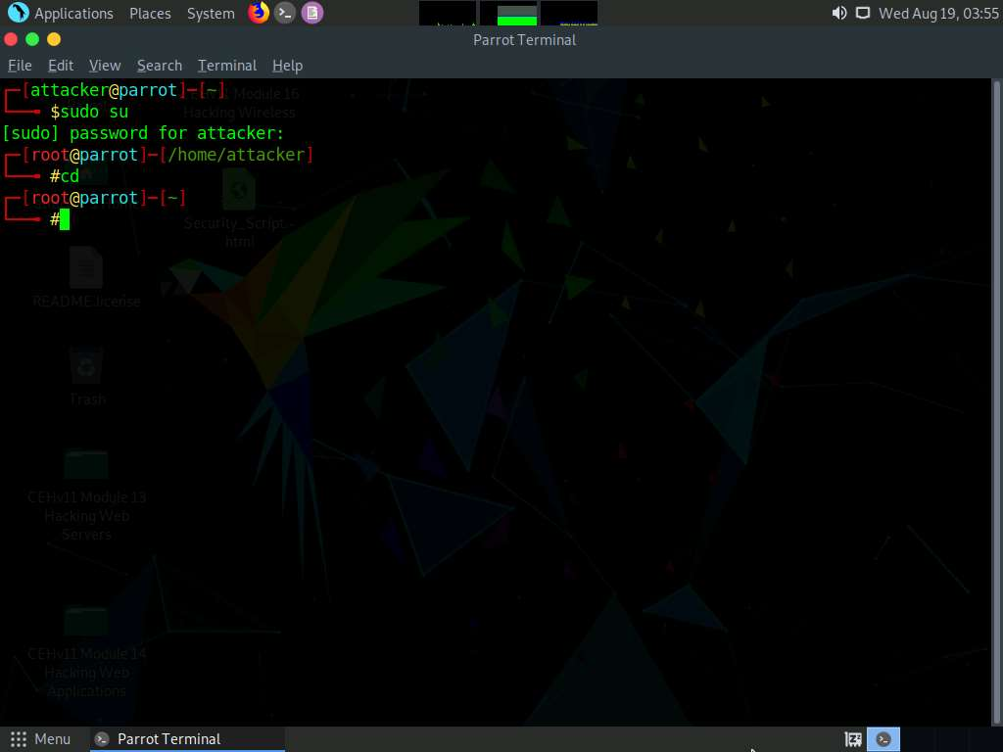

1. In the terminal window, type **cewl -d 2 -m 5 www.certifiedhacker.com** and press **Enter**.

**-d** represents the depth to spider the website (here, **2**) and **-m** represents minimum word length (here, **5**).

1. A unique wordlist from the target website is gathered, as shown in the screenshot.

The minimum word length is 5, and the depth to spider the target website is 2.

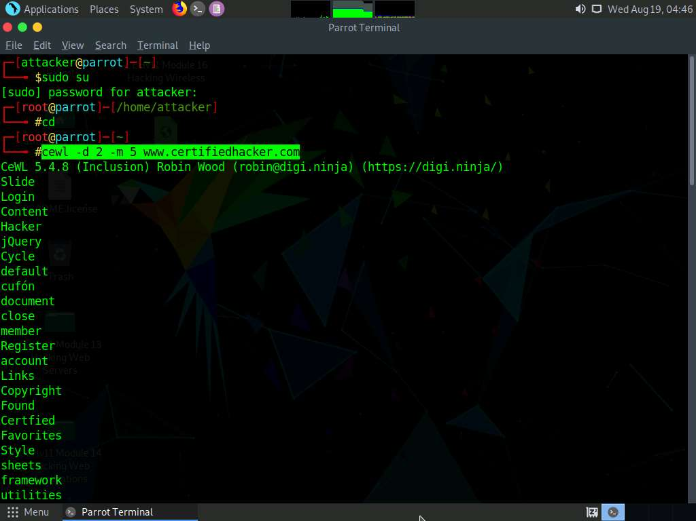

1. Alternatively, this unique wordlist can be written directly to a text file. To do so, type **cewl -w wordlist.txt -d 2 -m 5 www.certifiedhacker.com** and press **Enter**.

**-w** - Write the output to the file (here, **wordlist.txt**)

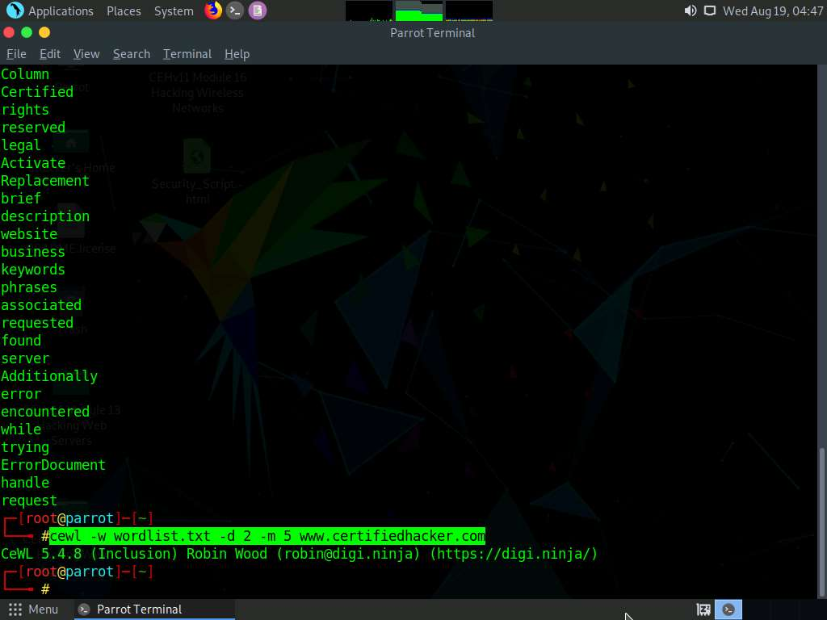

1. By default, the wordlist file gets saved in the **root** directory. Type **pluma wordlist.txt** and press **Enter** to view the extracted wordlist.

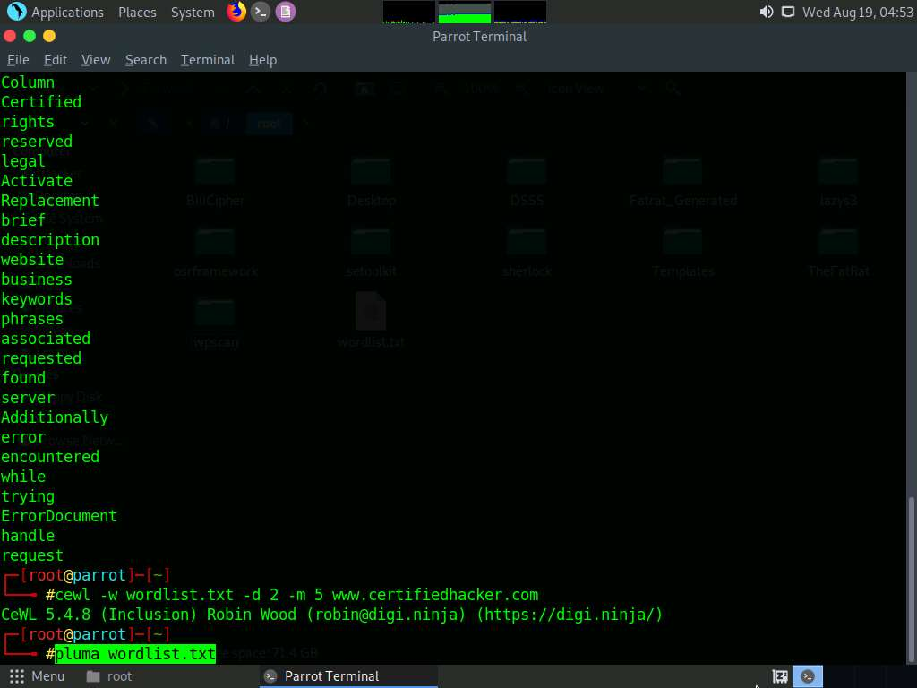

1. The file containing a unique wordlist extracted from the target website opens, as shown in the screenshot.

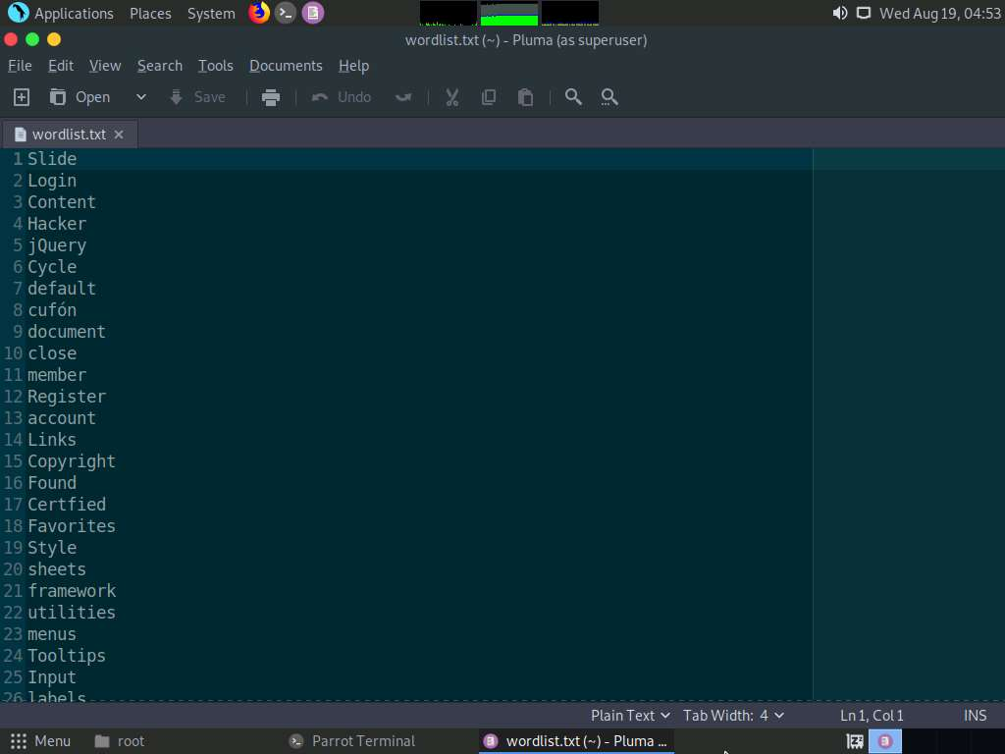

1. This wordlist can be used further to perform brute-force attacks against the previously obtained emails of the target organization’s employees.
2. This concludes the demonstration of gathering wordlist from the target website using CeWL.
3. Close all open windows and document all the acquired information.